[**https://explore.skillbuilder.aws/learn/course/1575/play/5240/getting-started-with-cloud-acquisition;lp=82**](https://explore.skillbuilder.aws/learn/course/1575/play/5240/getting-started-with-cloud-acquisition;lp=82)

**Introduction**

The cloud acquisition model is purposely different from traditional IT acquisition models. Cloud computing represents a fundamental shift in the way that organizations acquire computing facilities to operate business systems and digital services.

**Learning outcomes**

This course is built around five key sections: Cloud Acquisition Fundamentals, Procurement Foundations, Key Aspects of Procurement, Making It Real, and Working with Partners. Work through each section to enhance your cloud acquisition knowledge. As you build your knowledge, you will earn tools and badges to be able to build a house! Complete all the sections and pass the course knowledge assessment to complete your house. By the end of this course, you should be able to:

* Build cloud considerations into acquisition strategies.
* Identify how cloud acquisition affects all elements of your organization, from security to legal and finance.
* Describe different buying approaches and when to use them (frameworks, sole source, existing contracts, and dynamic purchasing systems).
* Recognize the value proposition of cloud service providers (CSPs) and their partners.
* Identify how and when to bring in partners and when it makes more sense to buy directly from a CSP.
* Identify the key stakeholders in your organization and how to effectively engage them on cloud acquisition considerations that might affect them.
* Recognize common acquisition questions and how to answer them.
* Work with the AWS Partner Network (APN Network).

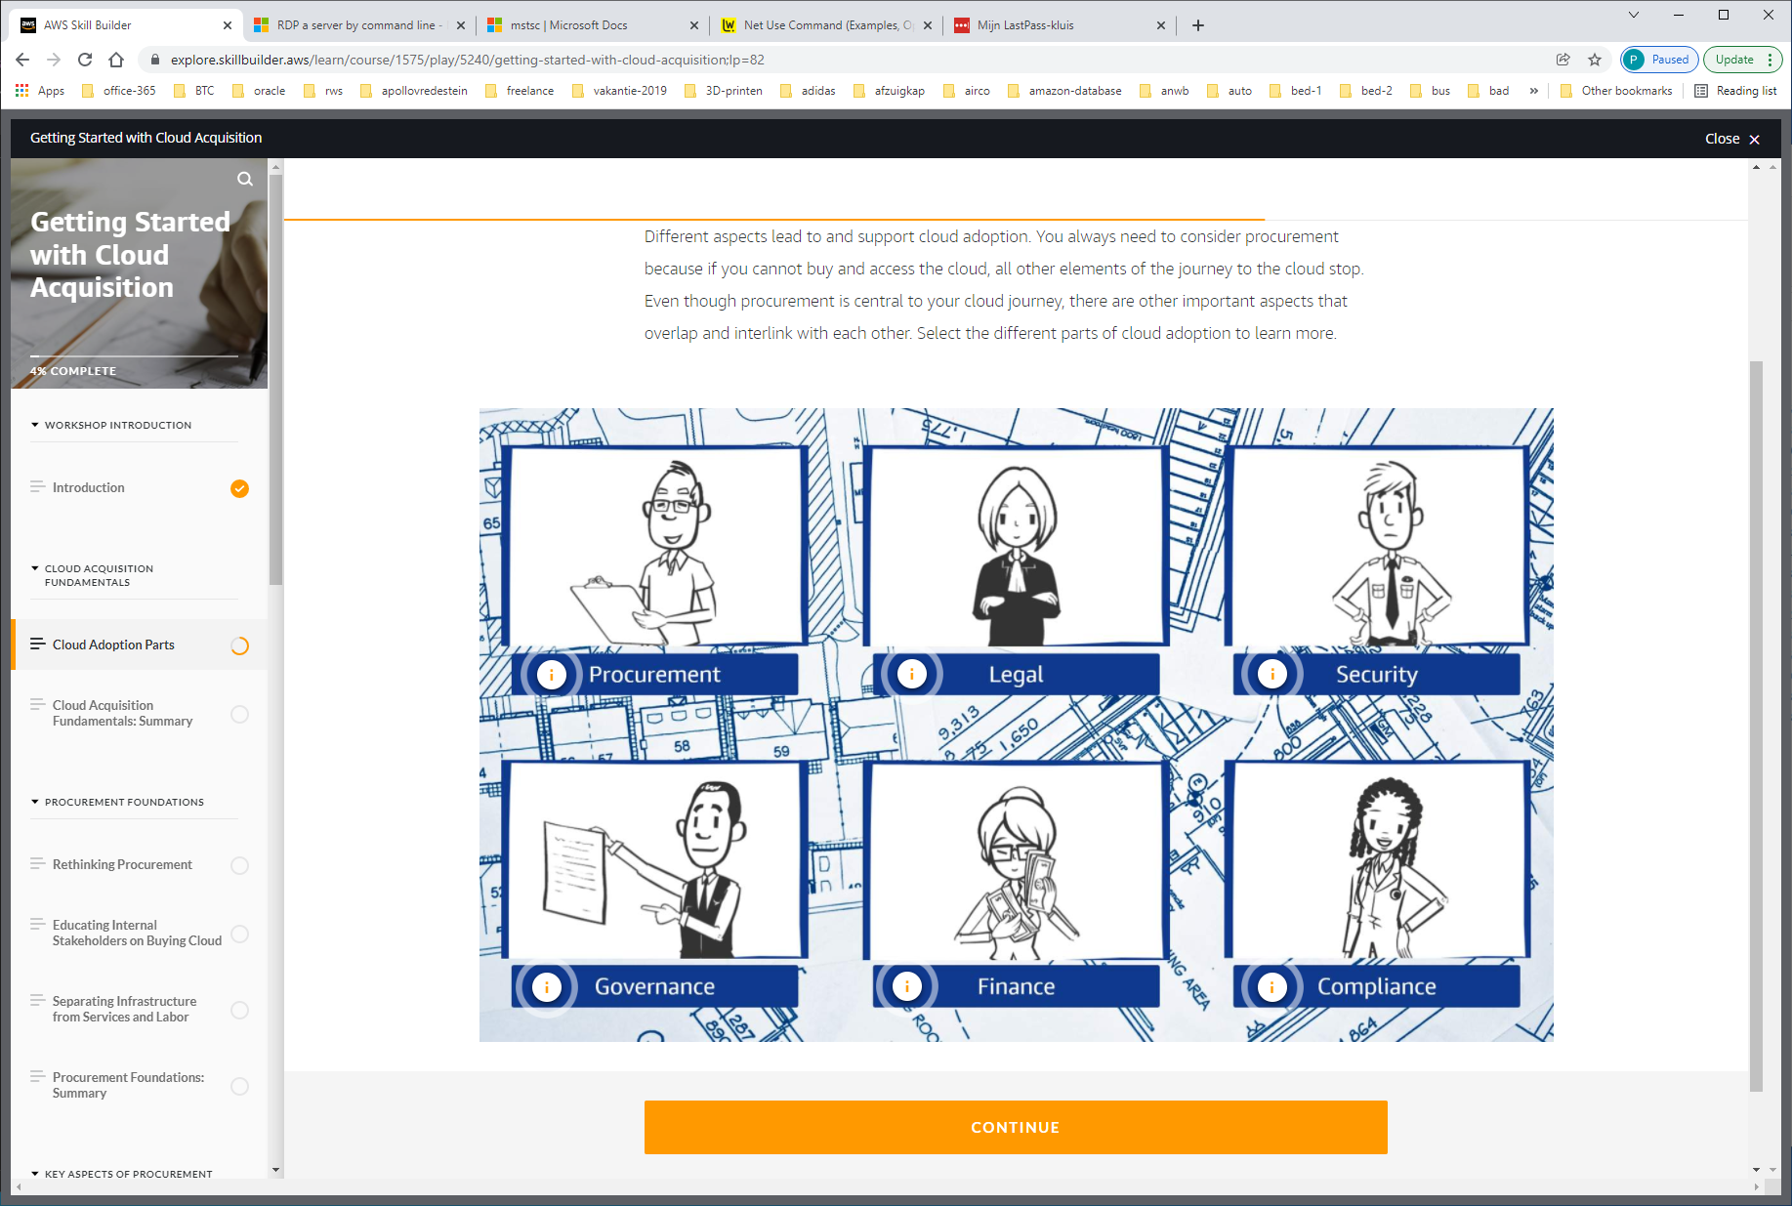

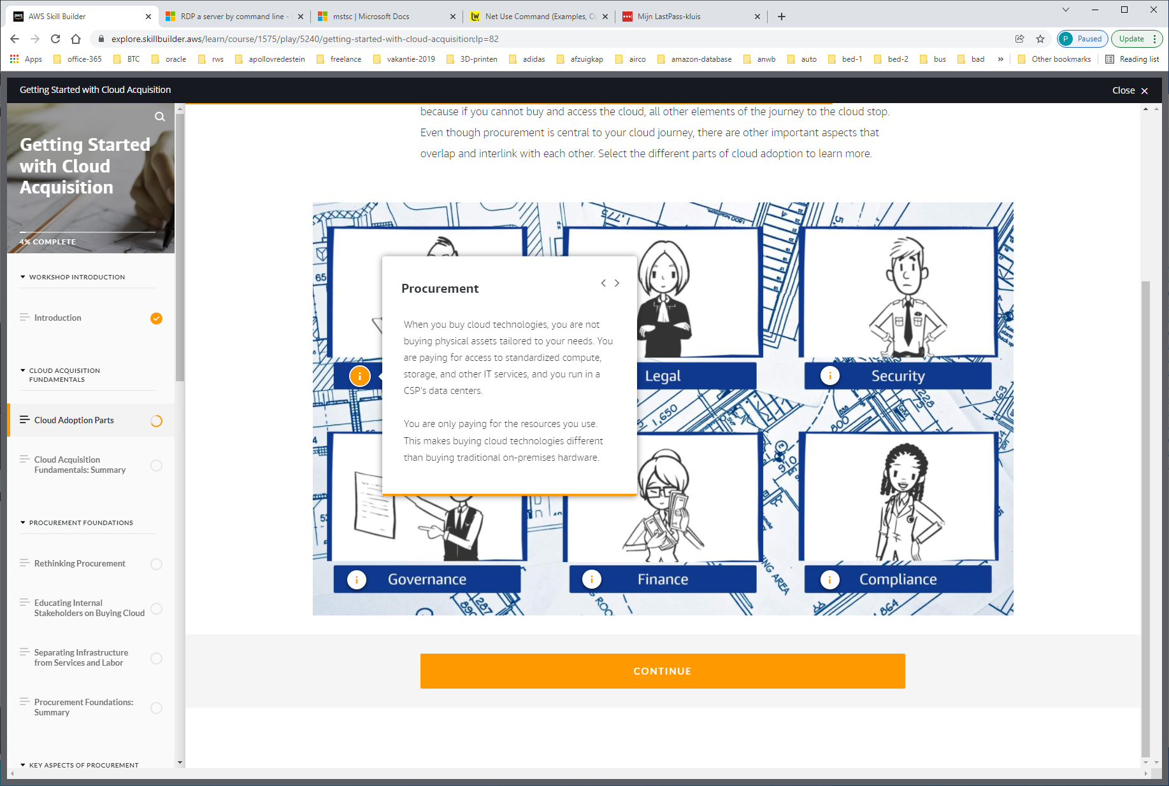

Procurement wordt gedefinieerd als: activiteiten gericht op het beheersen en sturen van de inkomende goederenstroom tot aan het moment dat de goederen in productie worden genomen. Procurement is een ruimer begrip dan purchasing en omvat tevens materiaalbehoefteplanning, voorraadbeheer en transport.

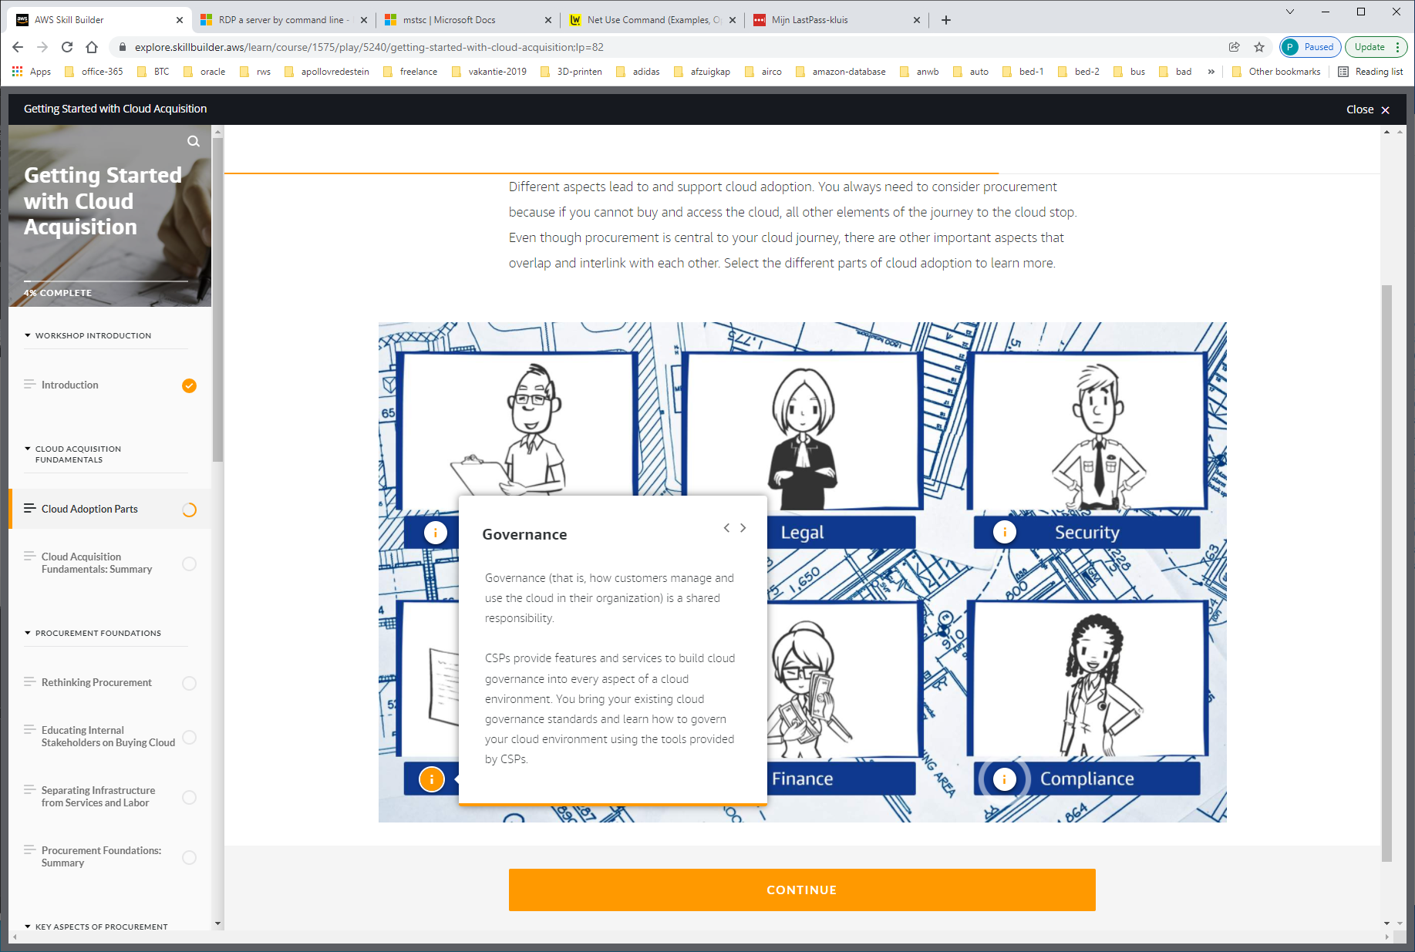

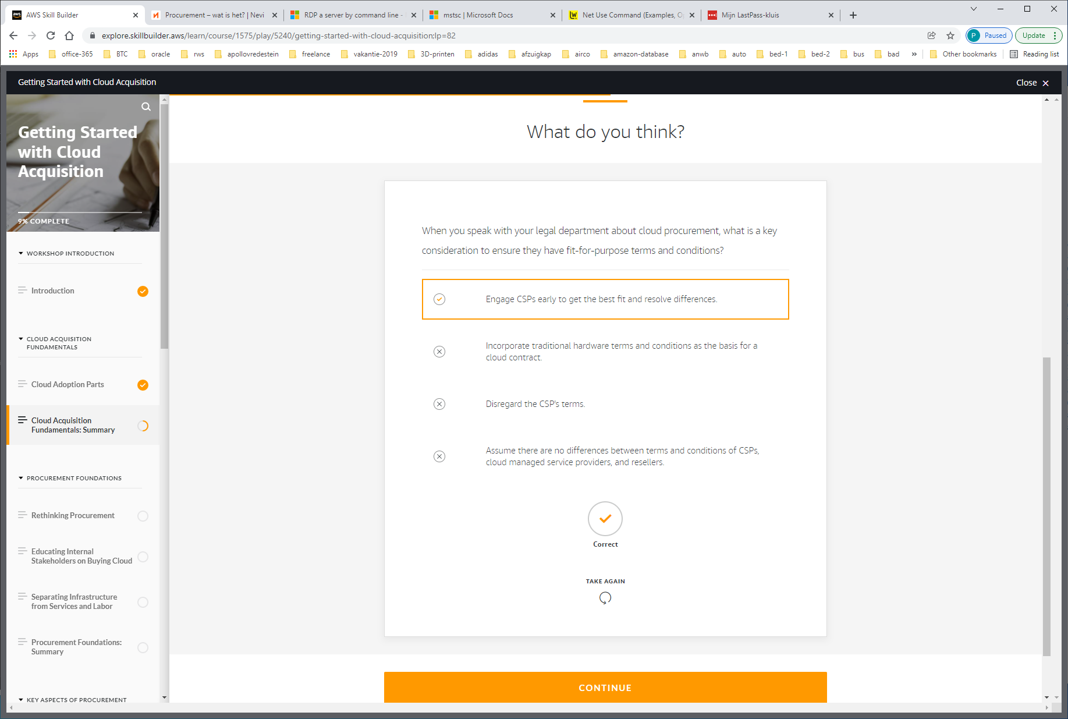

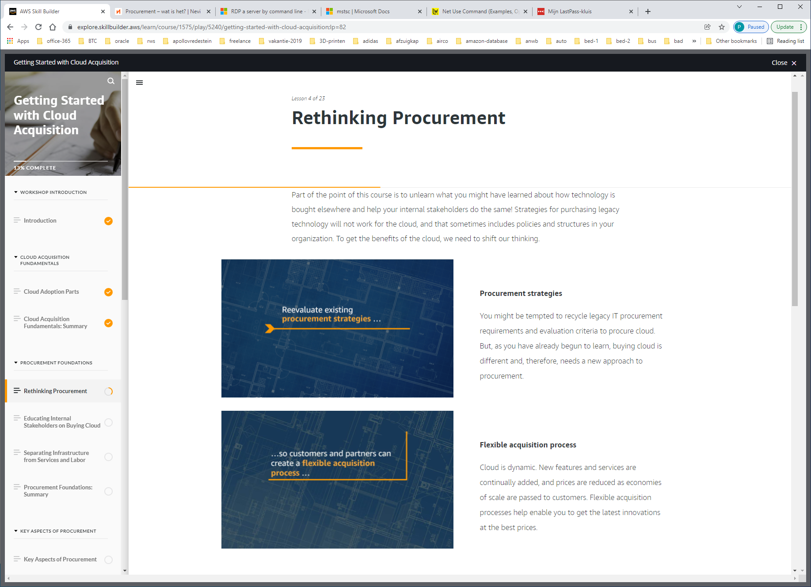

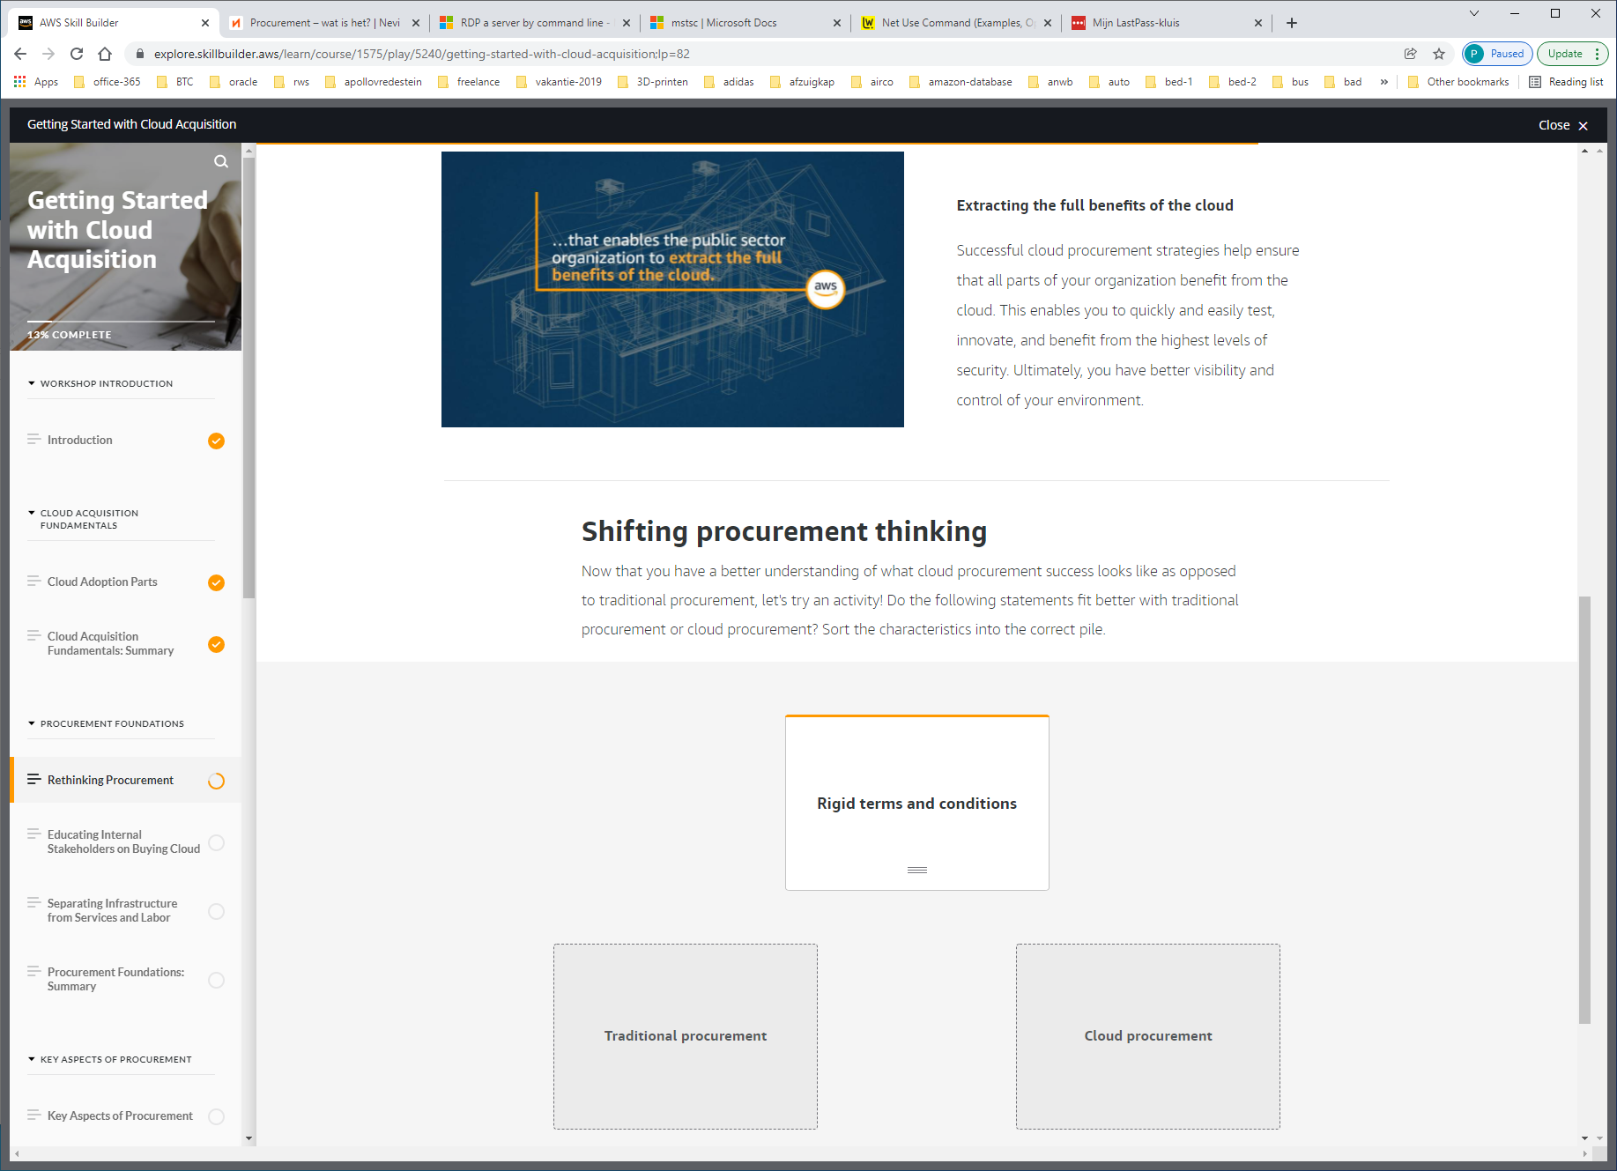

Tradition-proceurement: rigid terms and conditions  
 highly prescriptive  
 fixed pricing  
 predictable payment  
 lengthy (years)  
 risky adverse  
 traditional security approaches

Cloud-procurement: performance based   
 focused on benefits and users  
 outcomes prioritized  
 traditional approaches not recycled  
 rapid innovation  
 self-service and pay-as-you-go

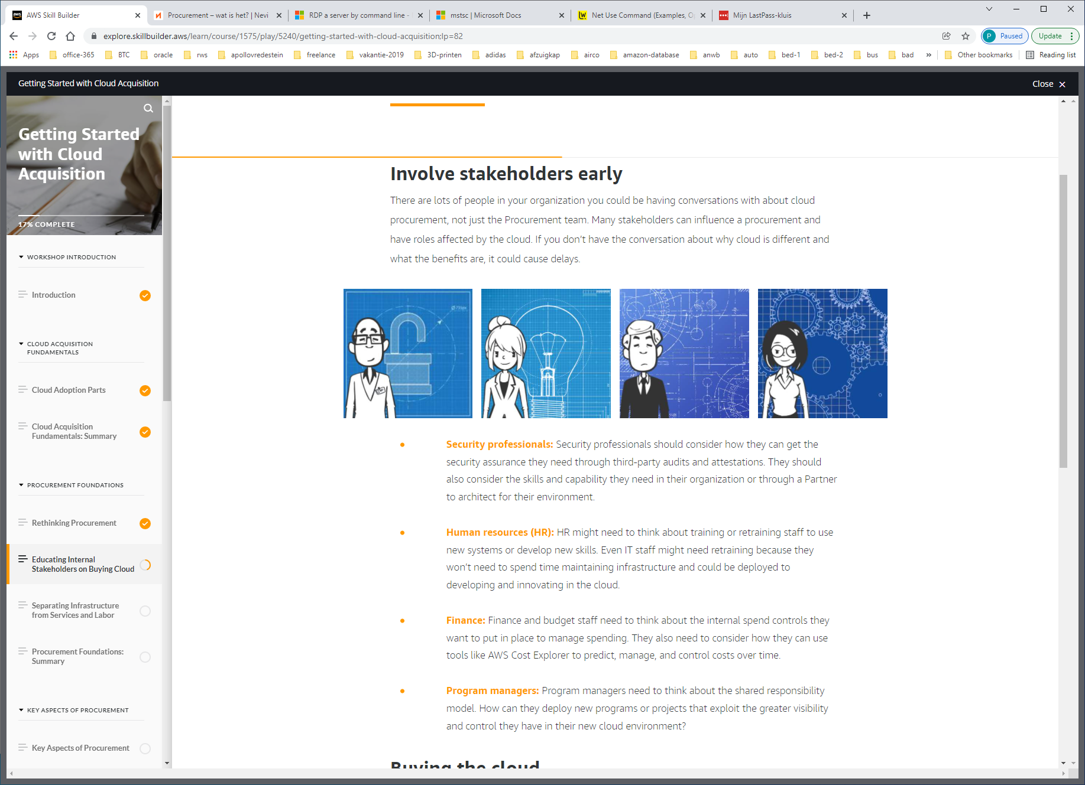

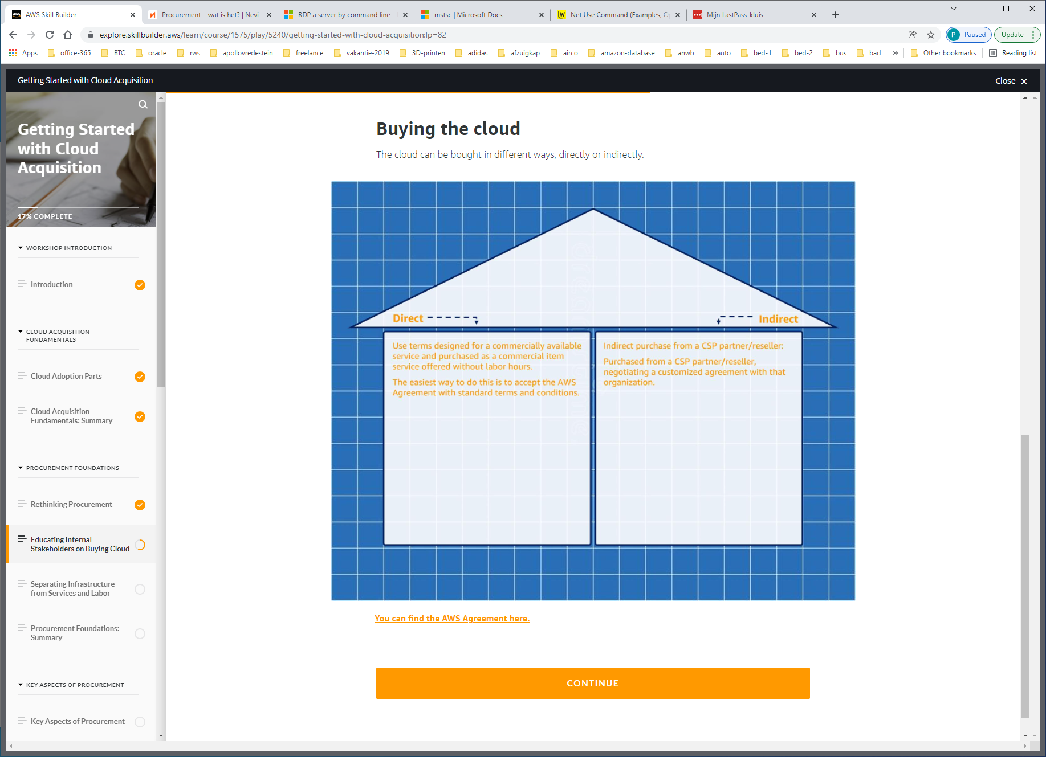

https://aws.amazon.com/agreement/

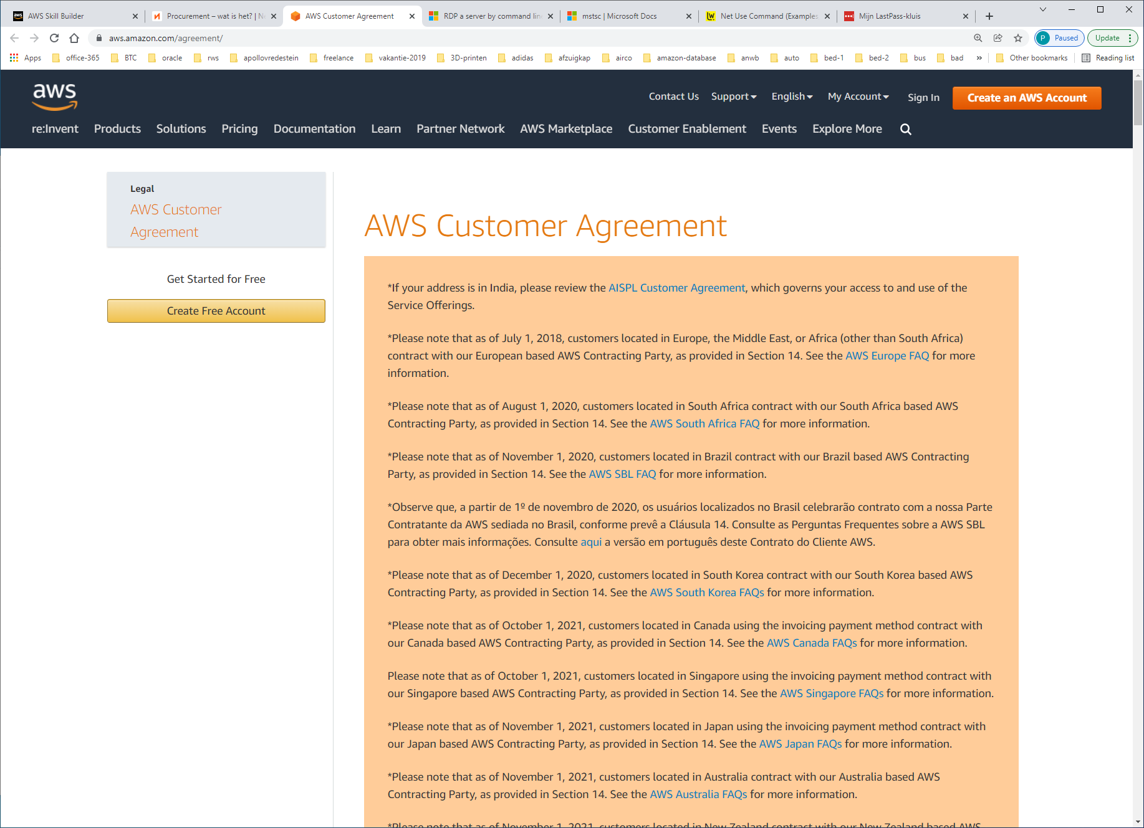

*Please note that as of July 1, 2018, customers located in Europe, the Middle East, or Africa (other than South Africa) contract with our European based AWS Contracting Party, as provided in Section 14. See the [AWS Europe FAQ](https://aws.amazon.com/legal/aws-emea/) for more information.

# Separating Infrastructure from Services and Labor

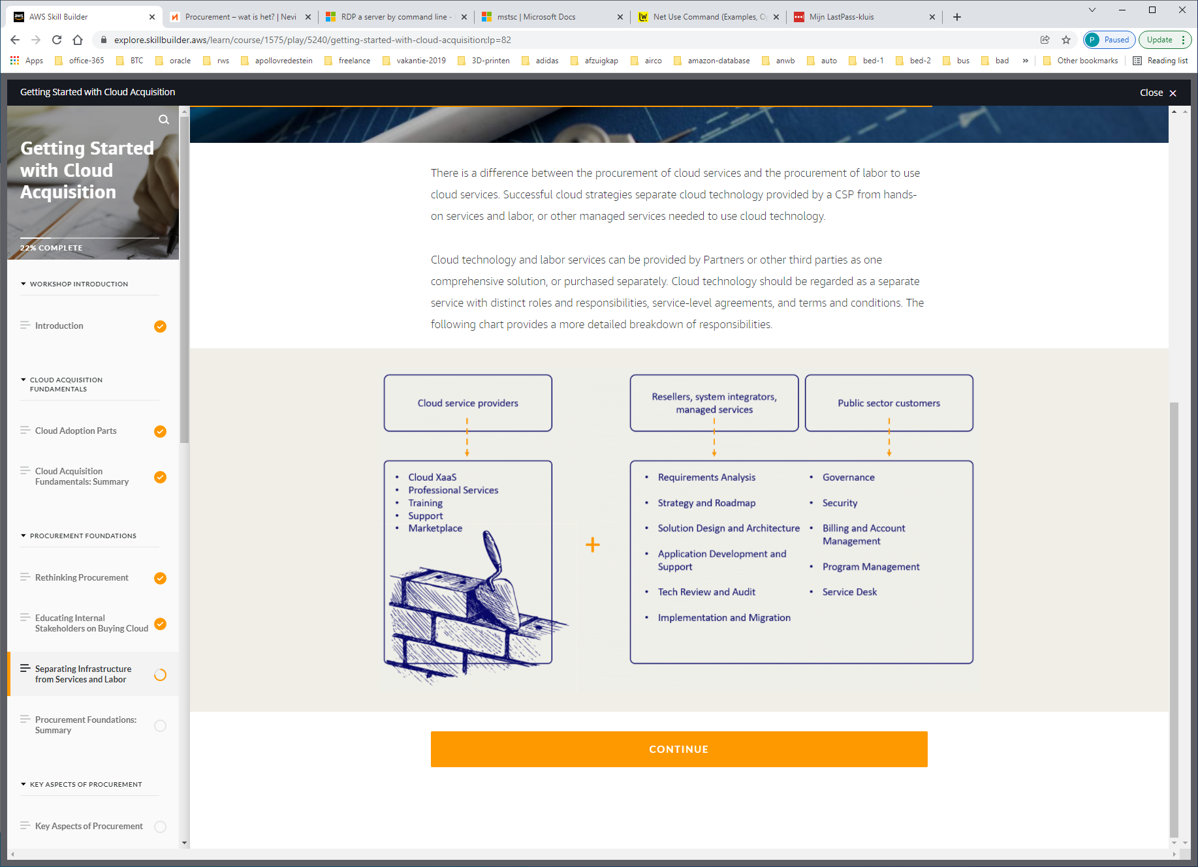

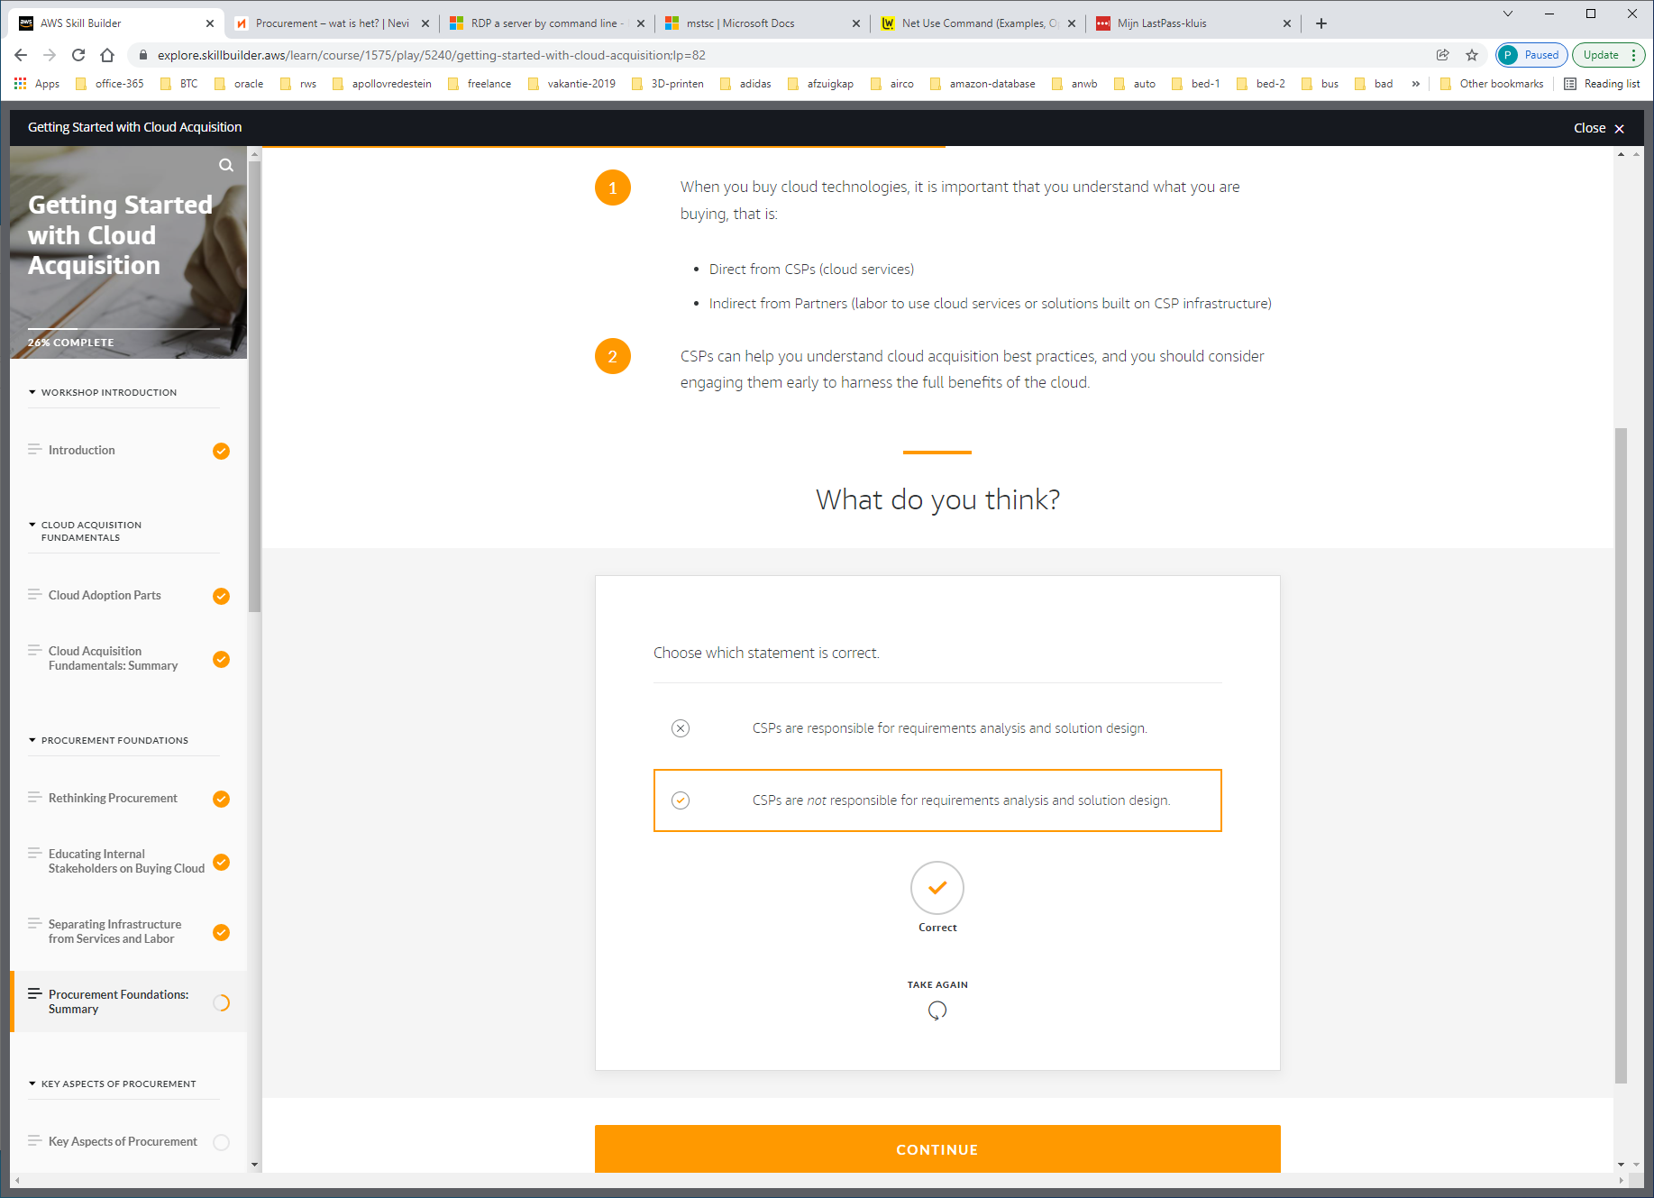

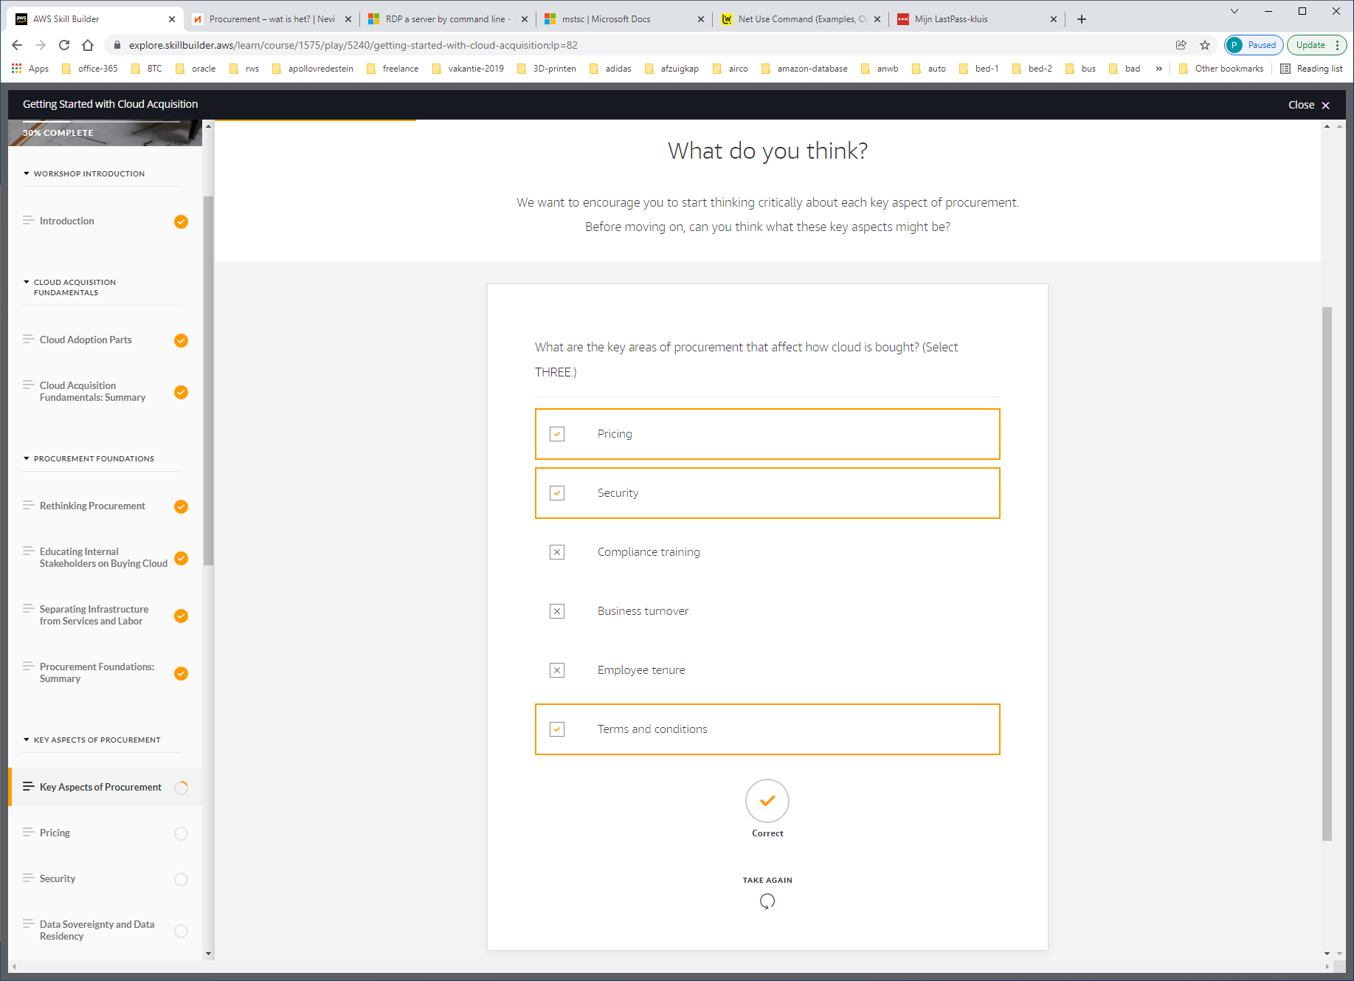

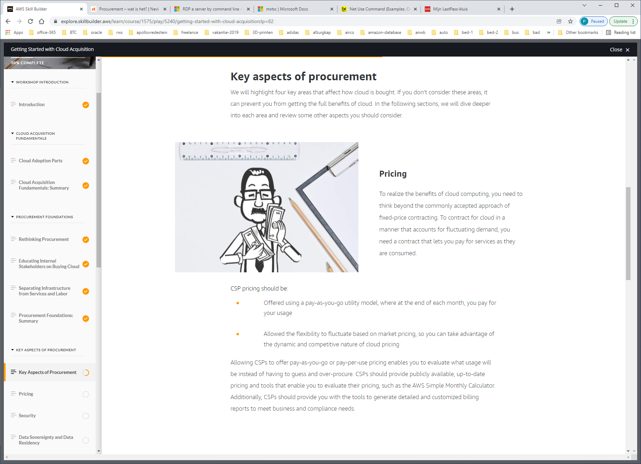

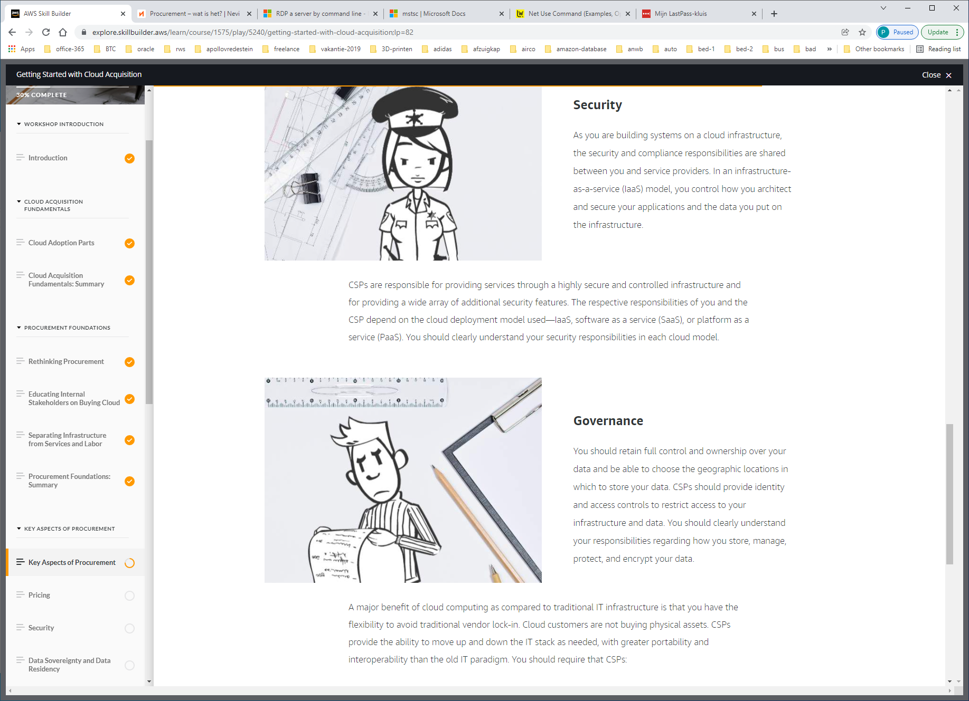

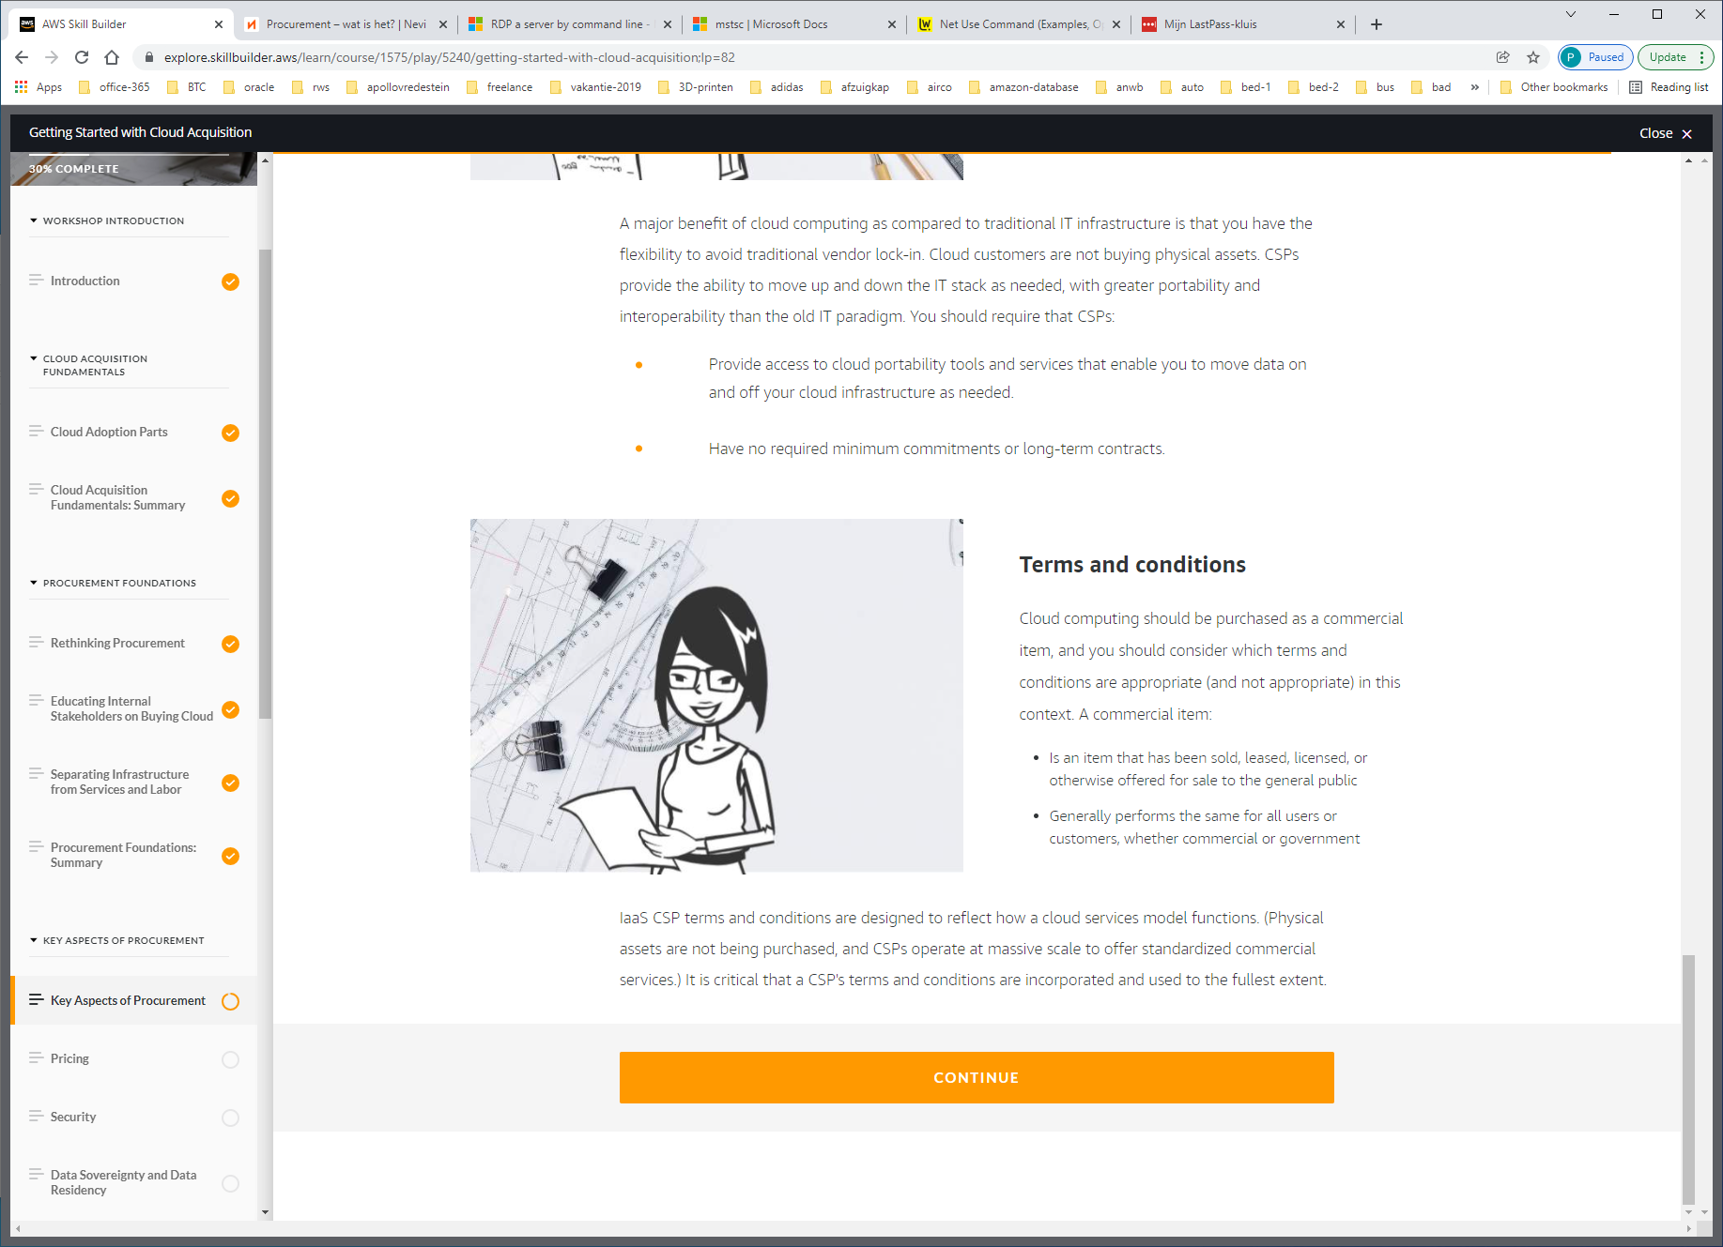

PRICING

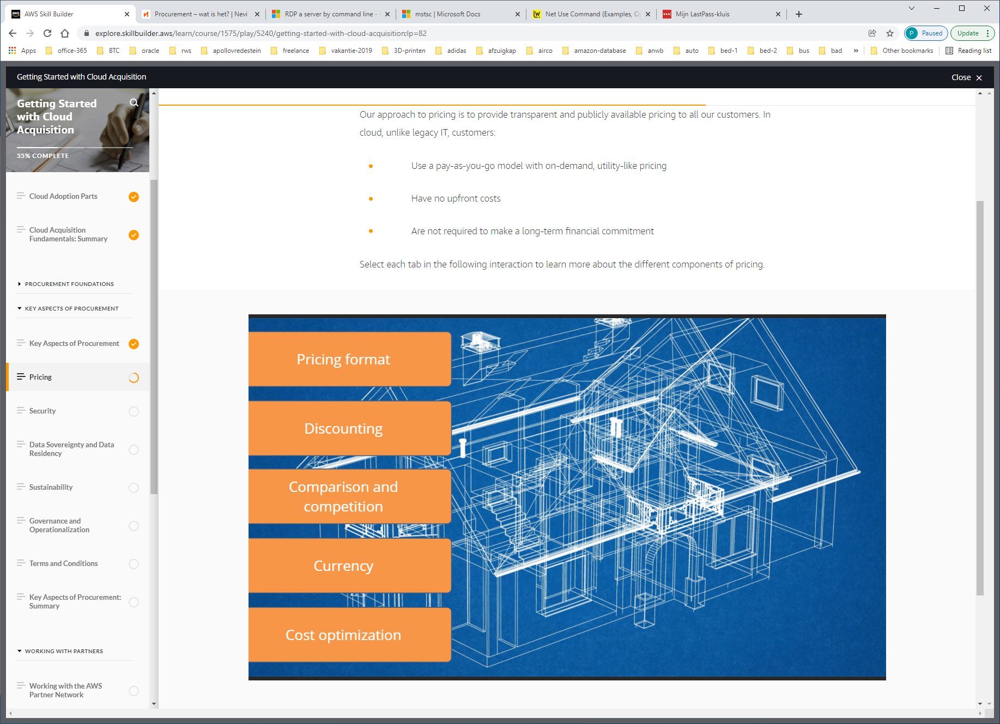

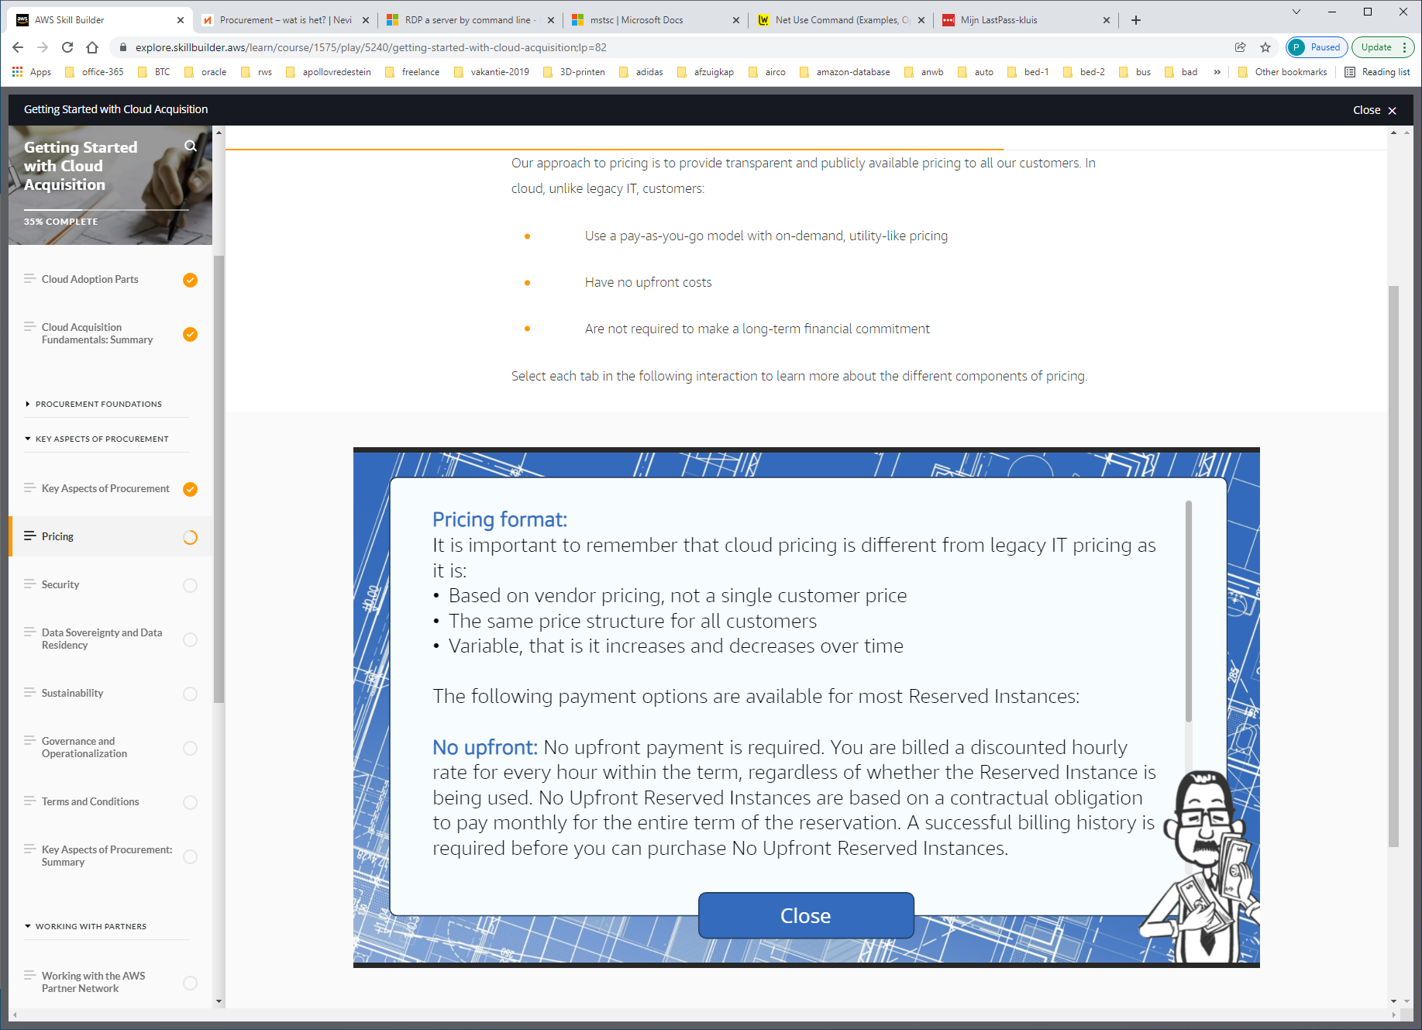

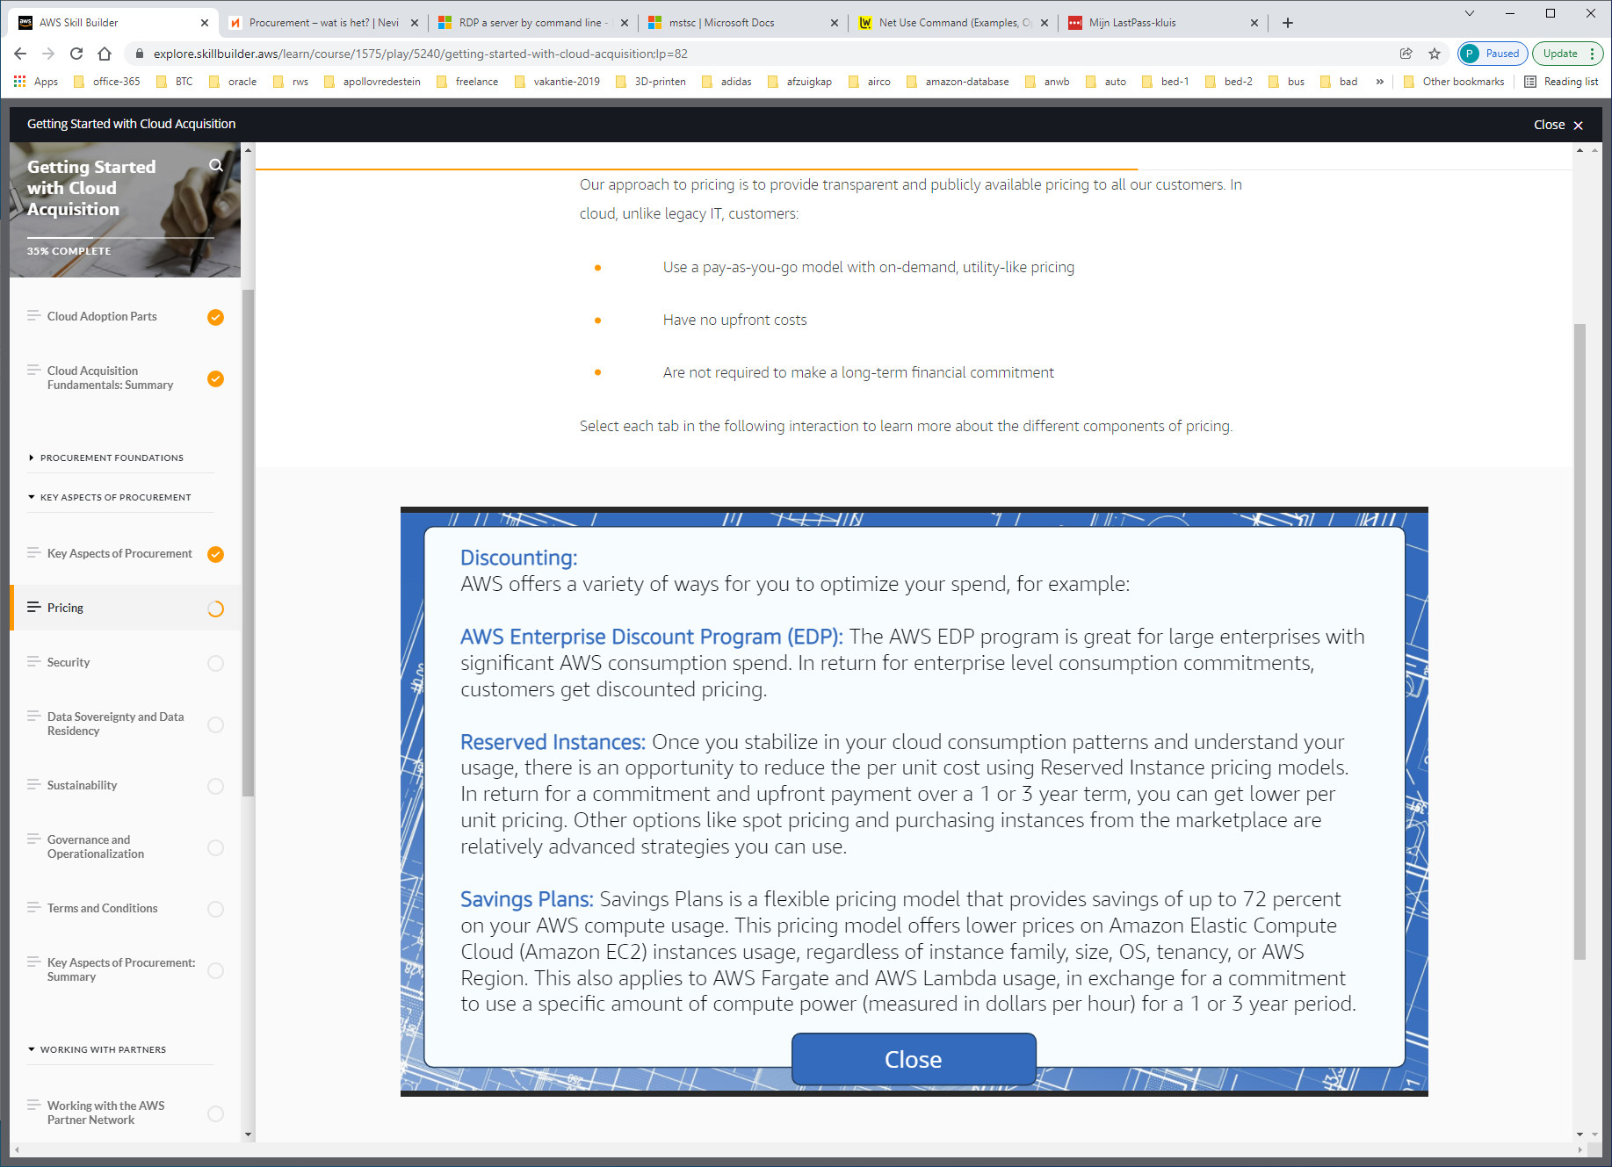

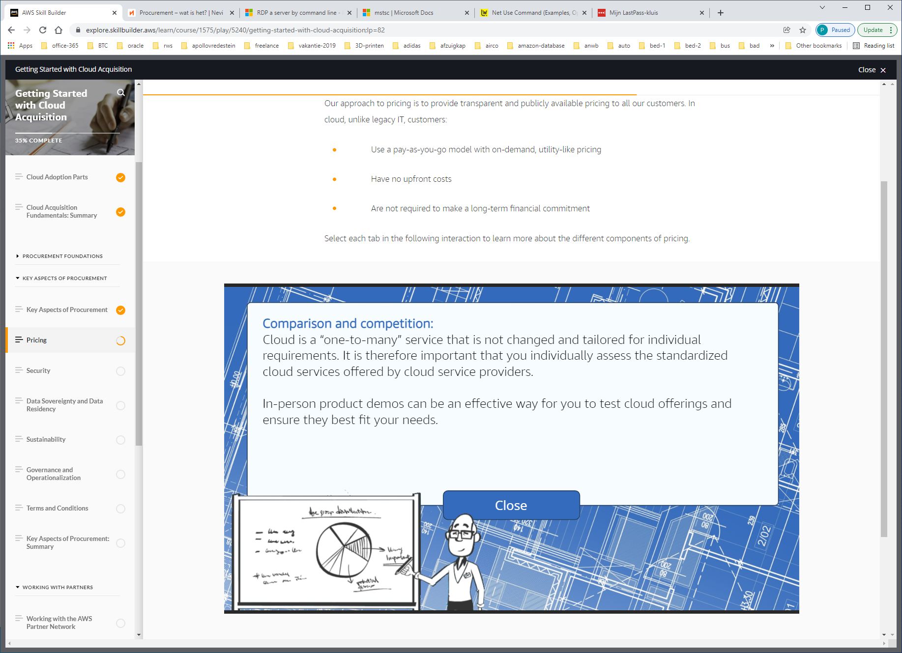

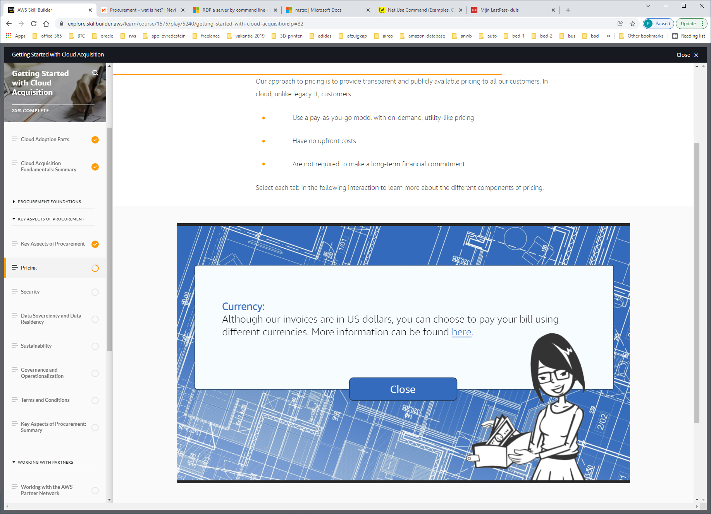

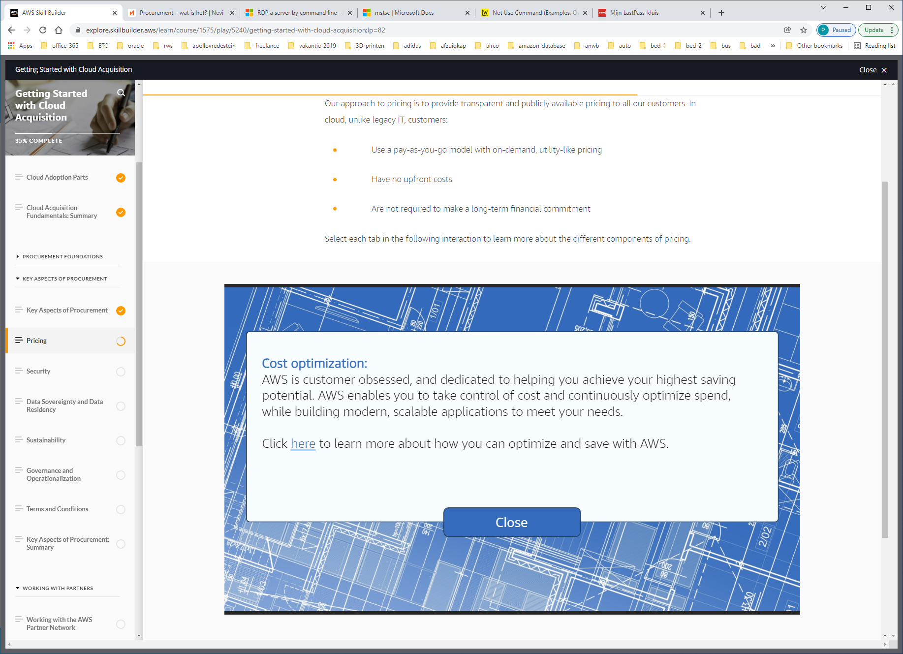

Security

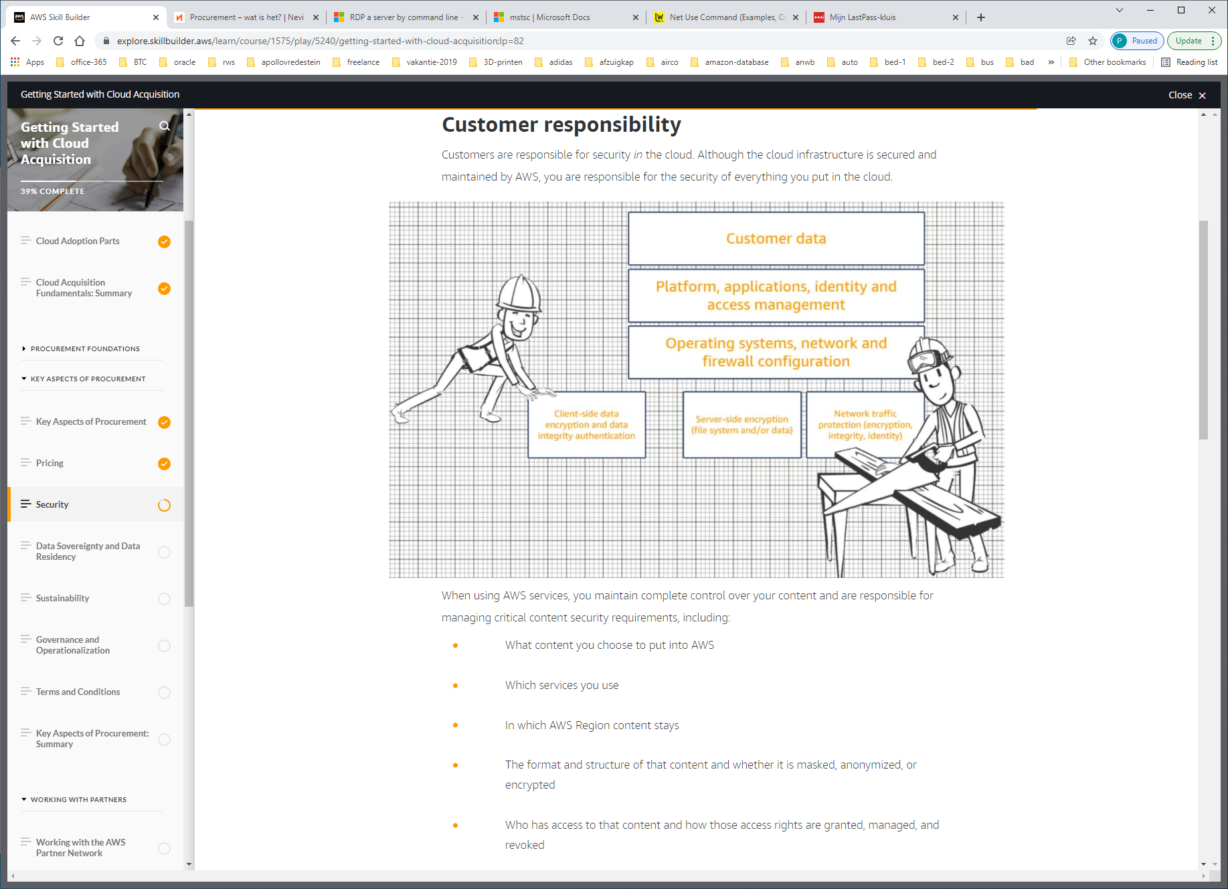

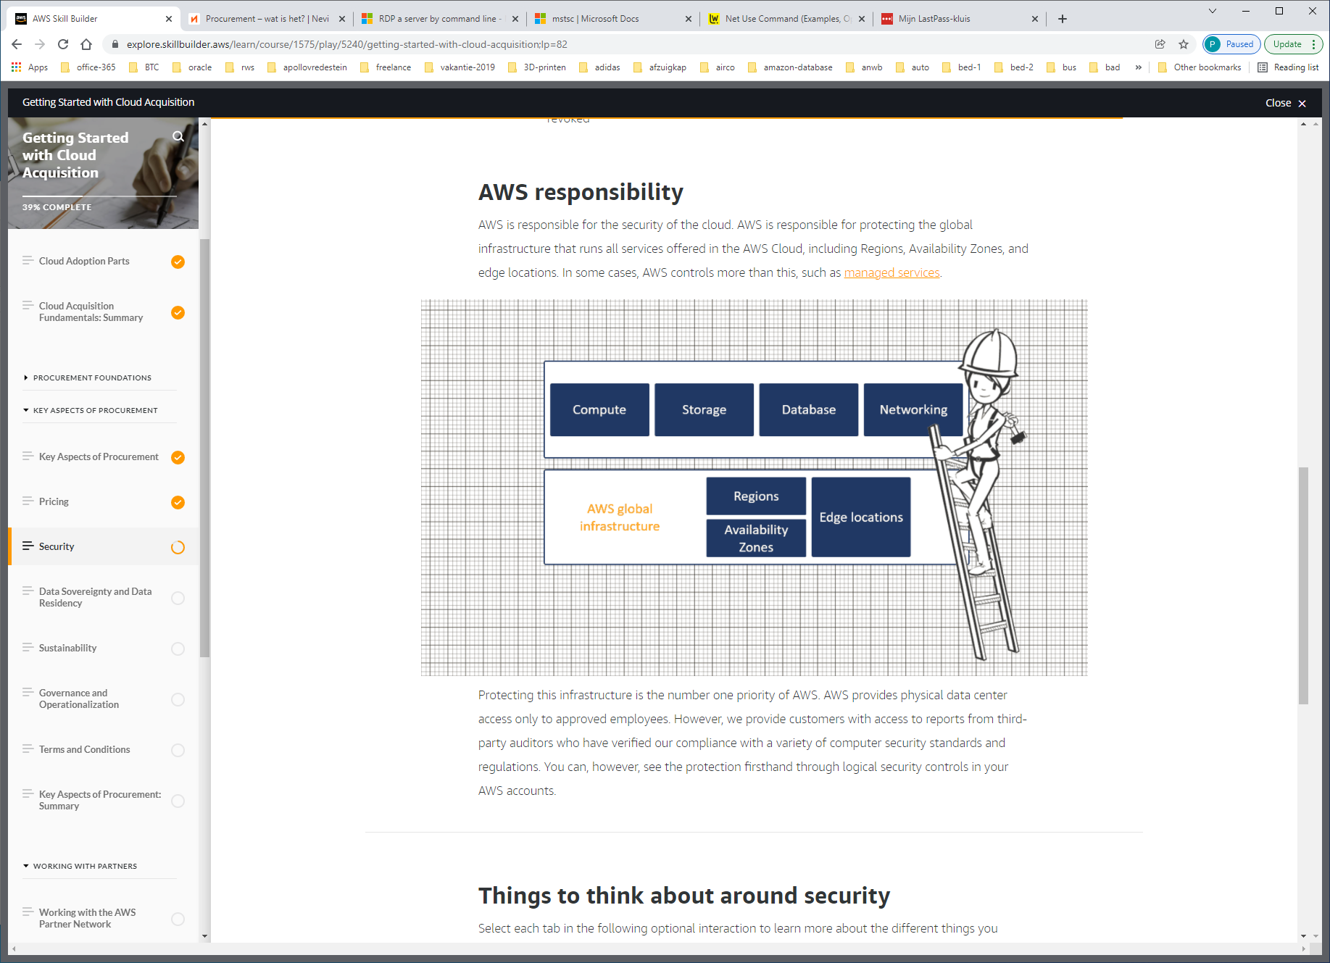

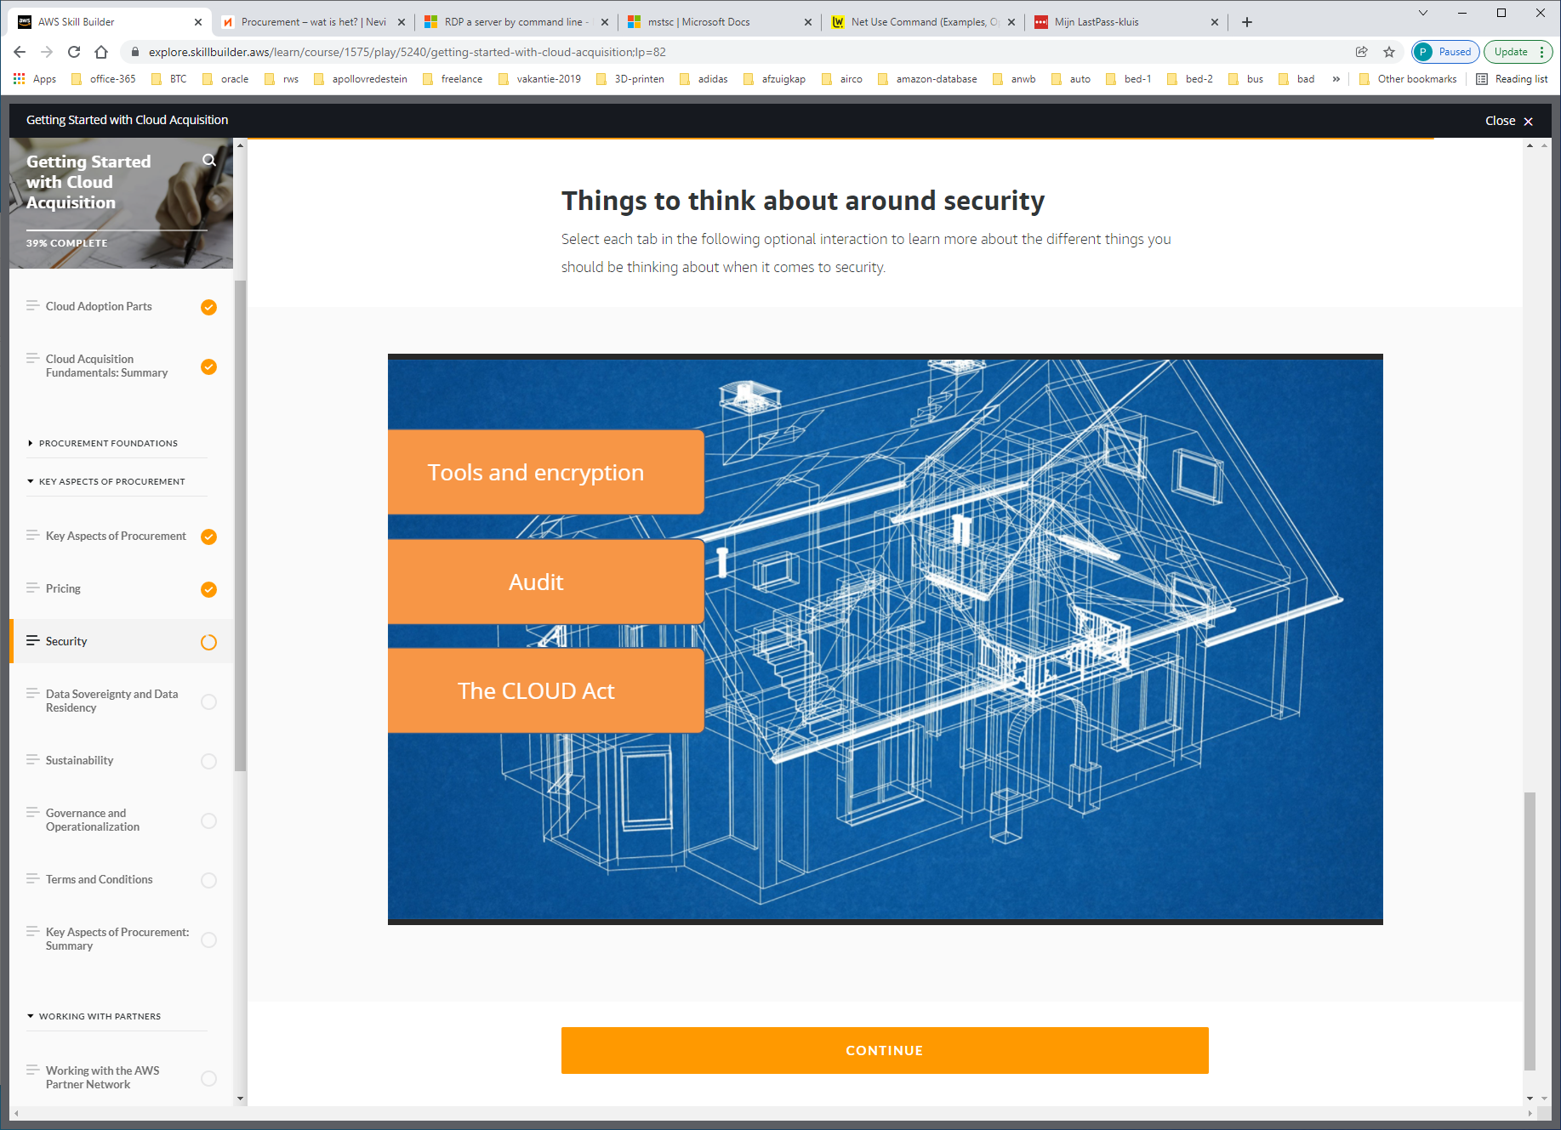

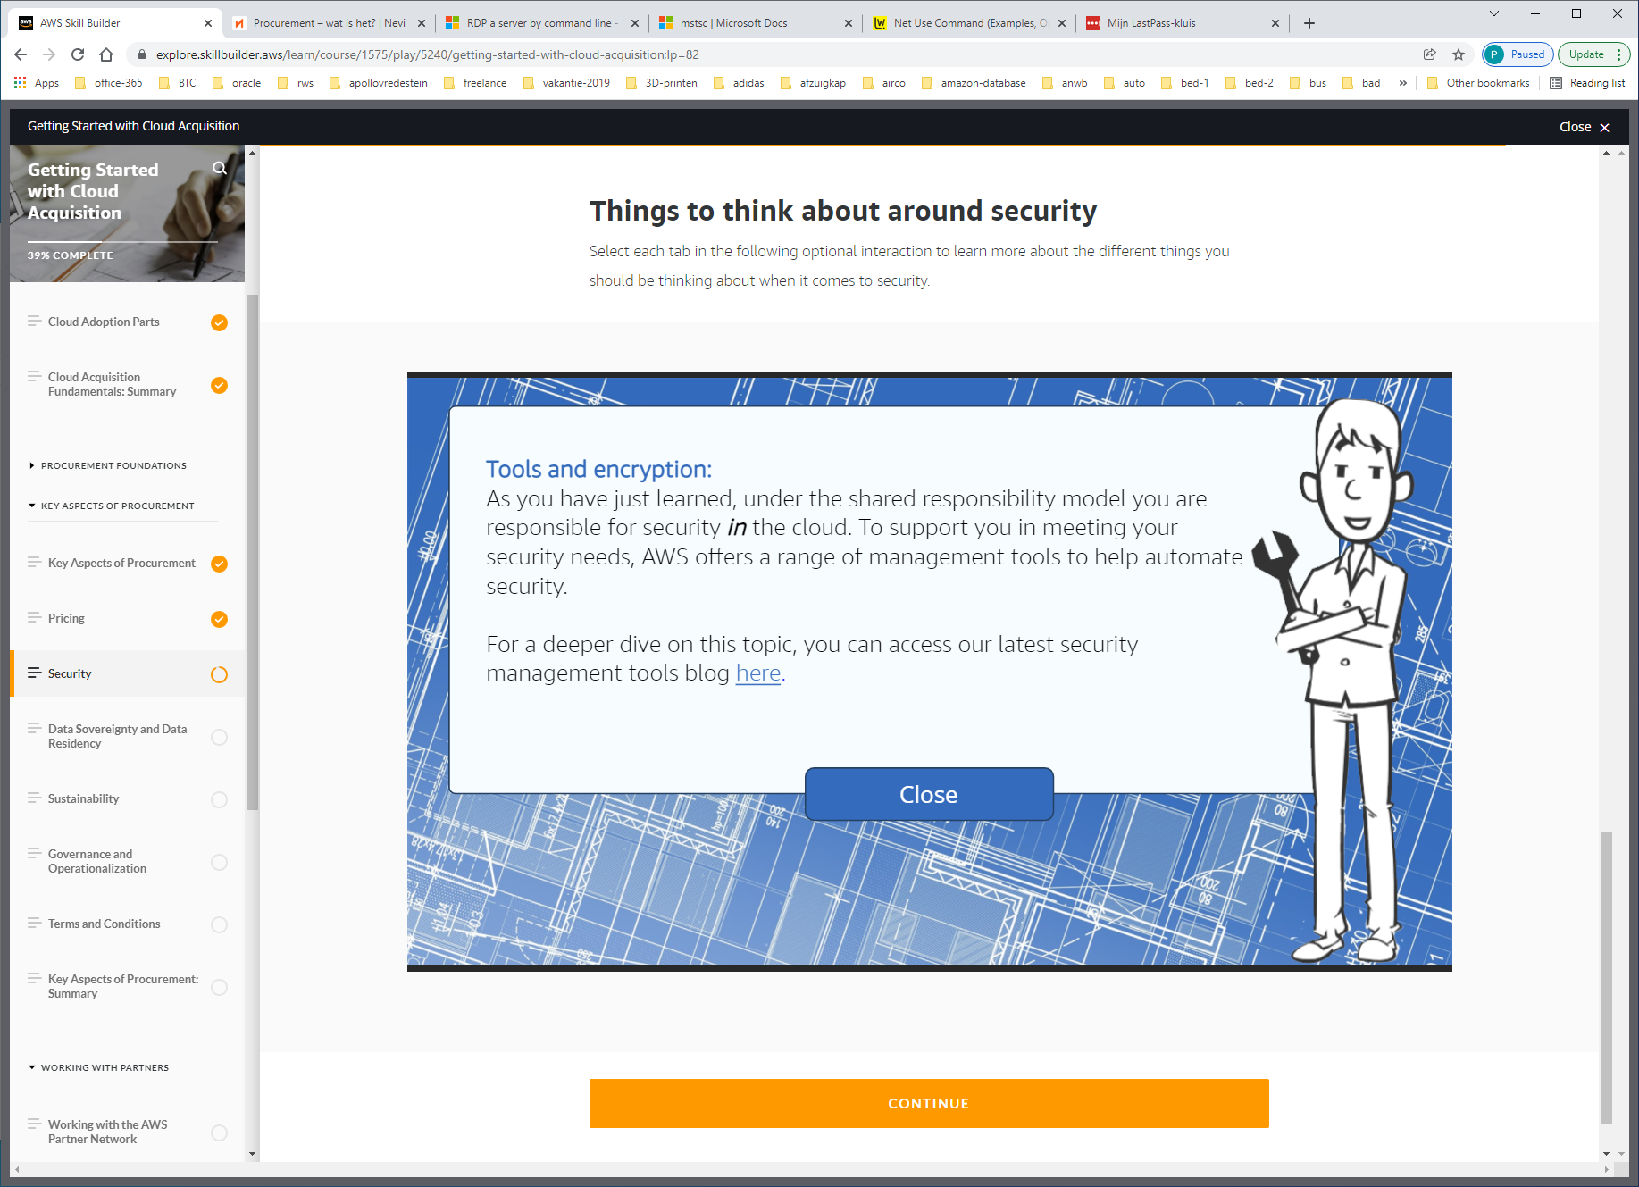

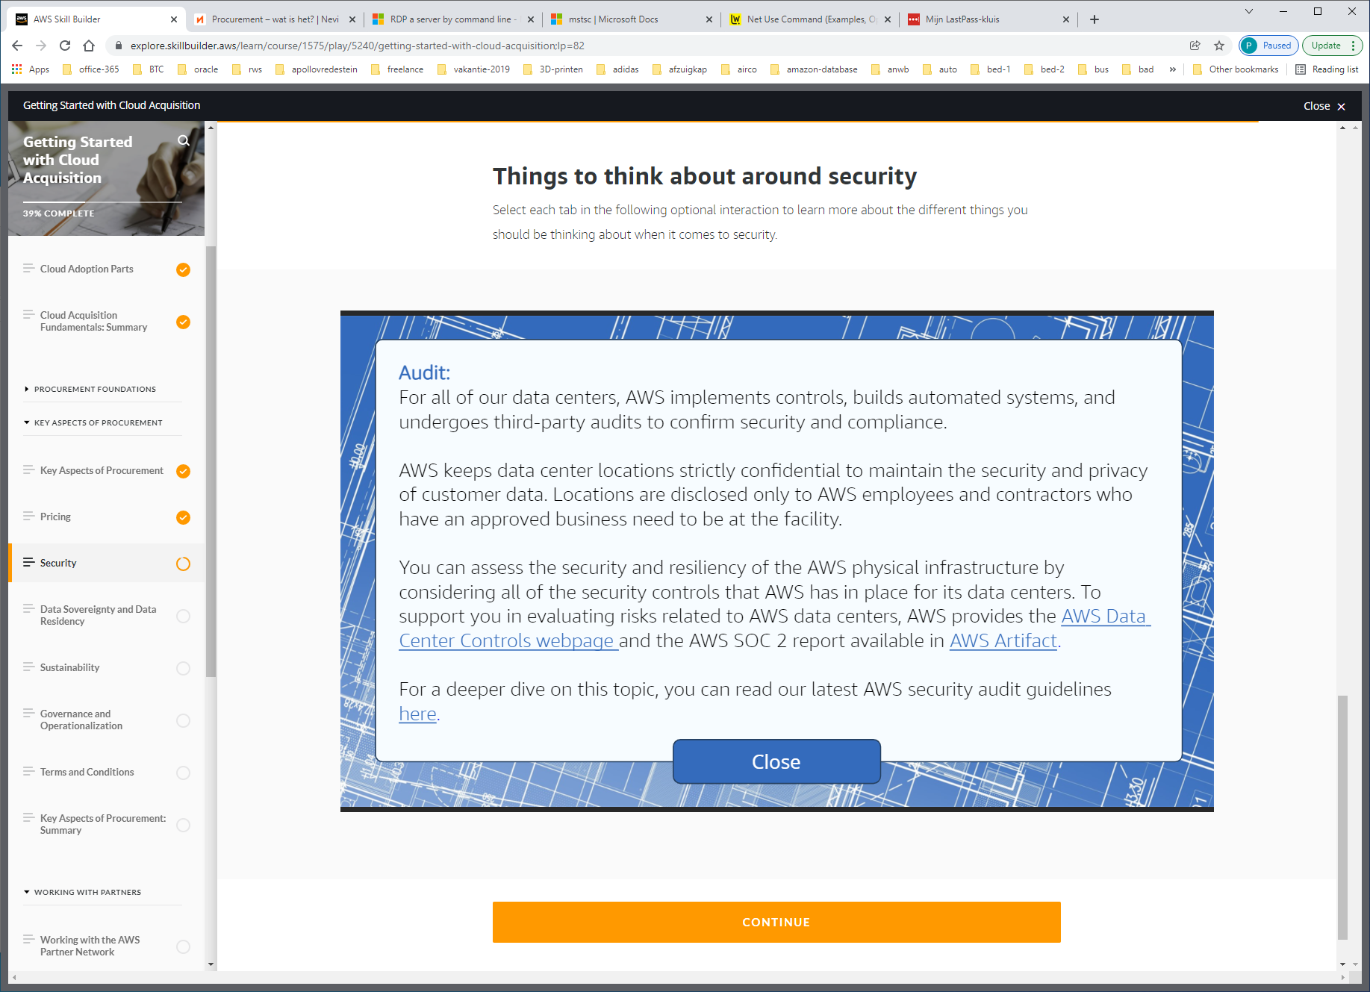

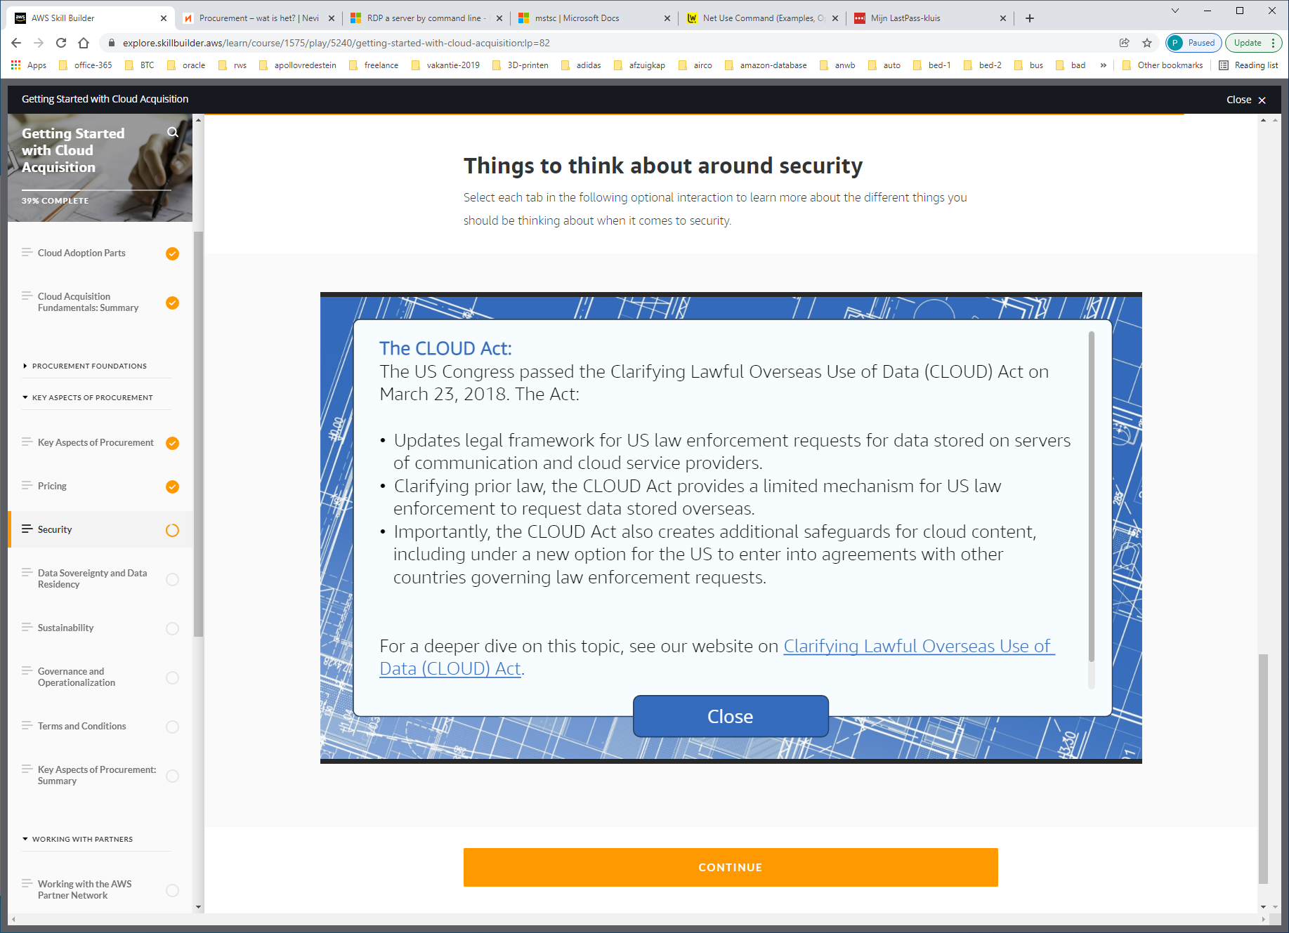

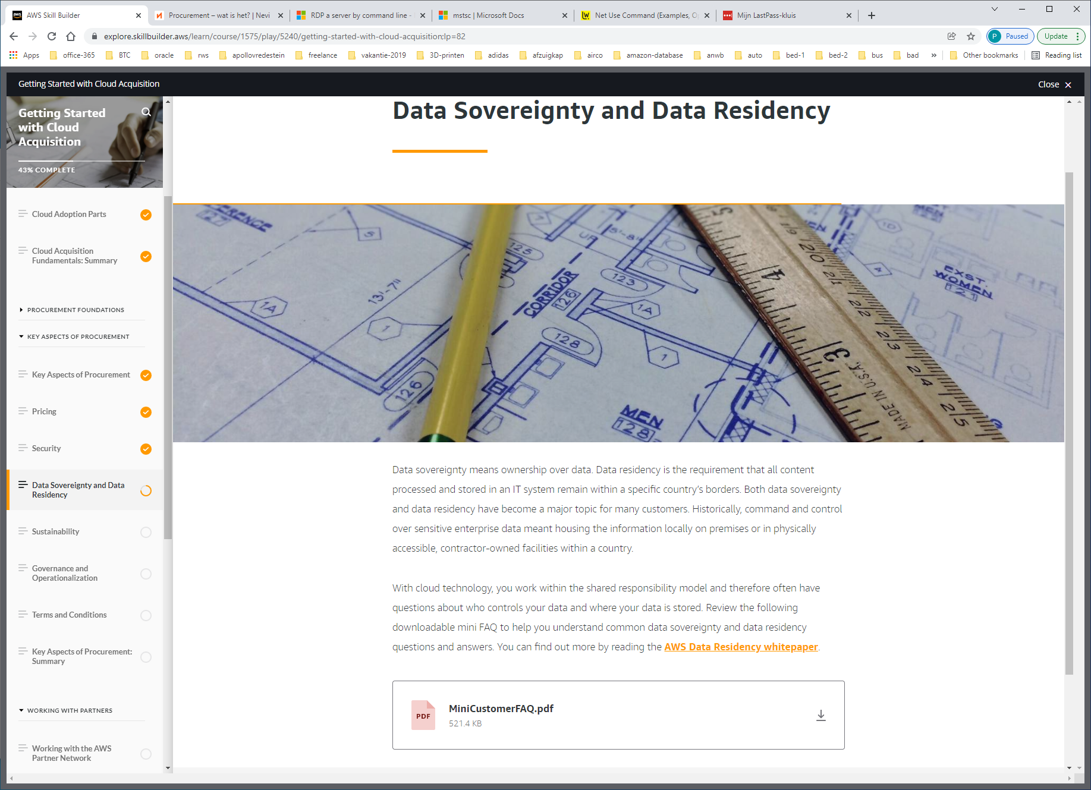

Data sovereignty means ownership over data. Data residency is the requirement that all content processed and stored in an IT system remain within a specific country’s borders.

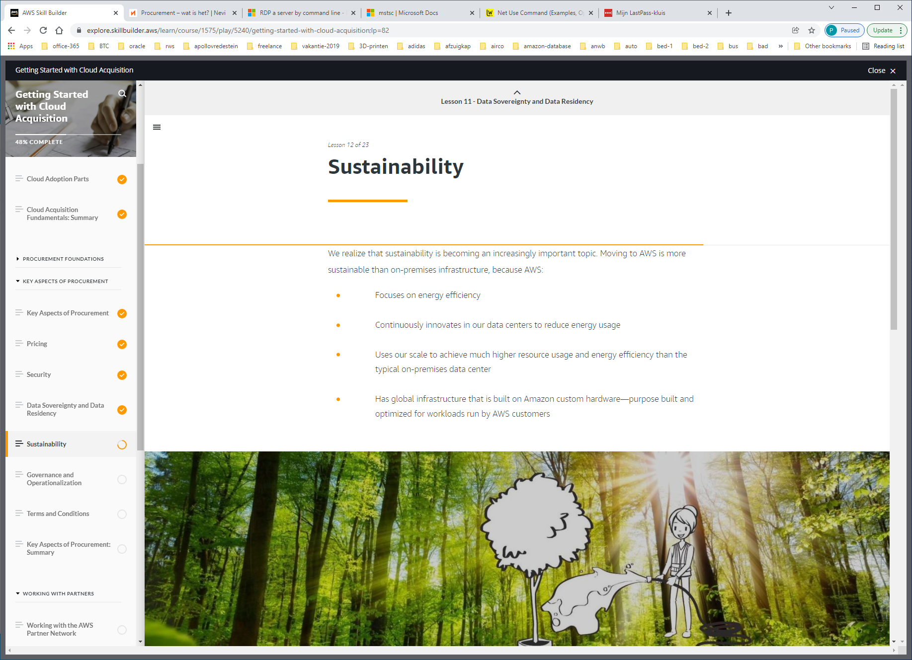

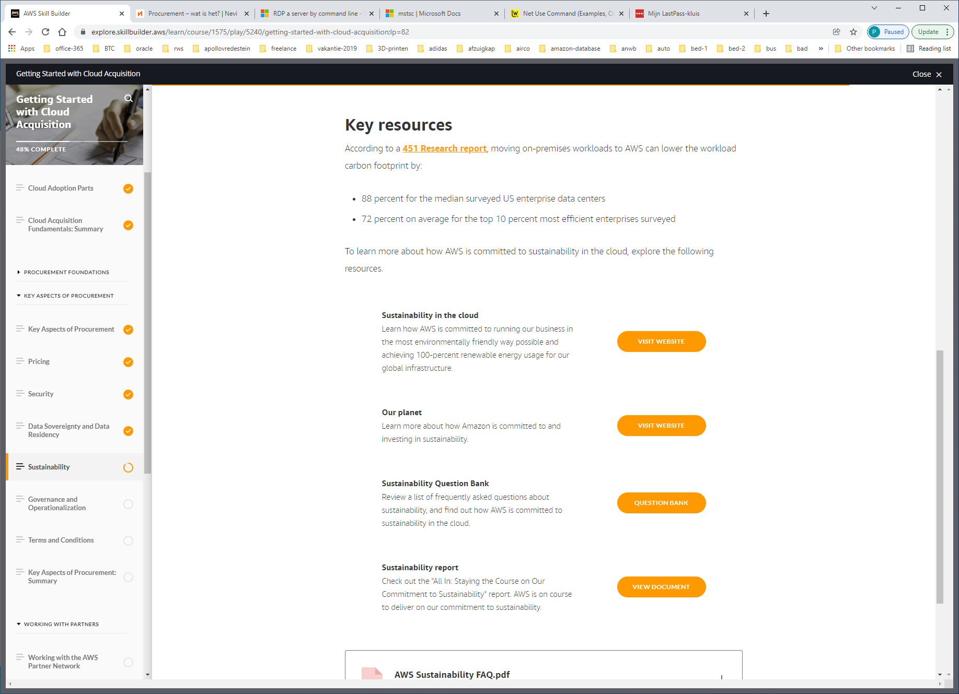

https://sustainability.aboutamazon.com/environment/the-cloud?energyType=true

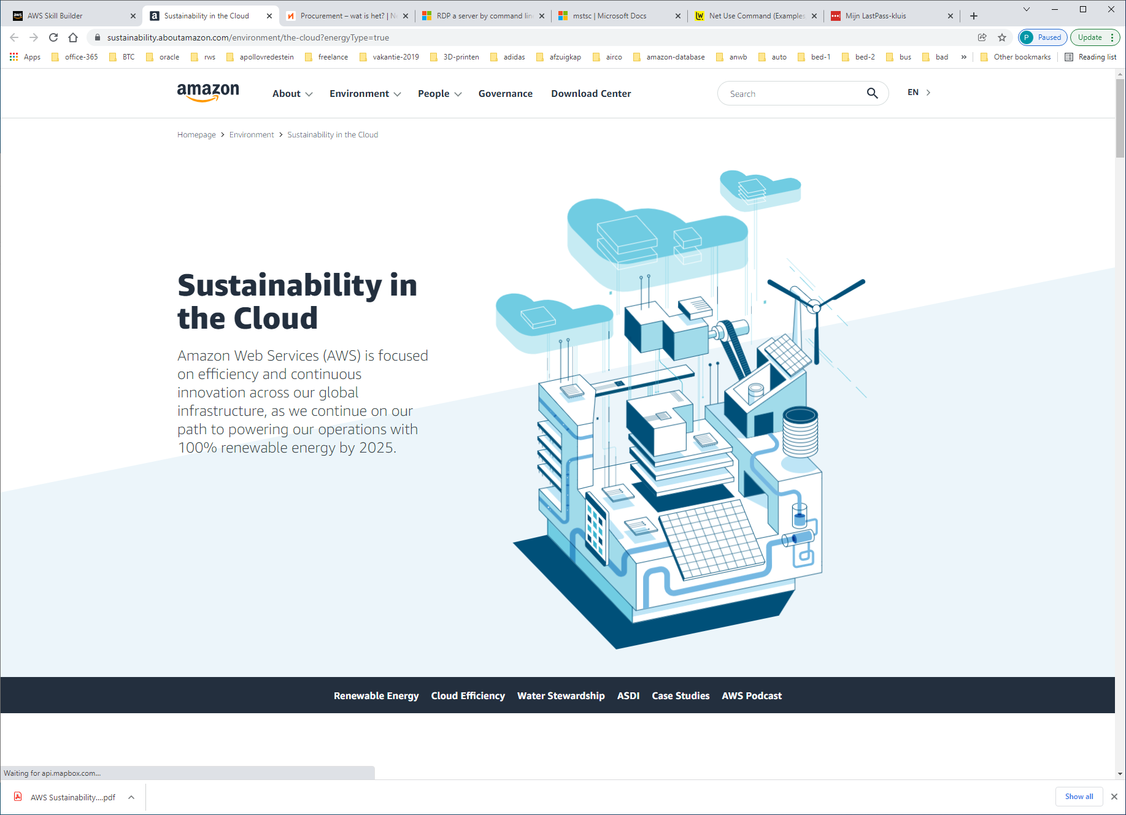

https://www.aboutamazon.com/planet

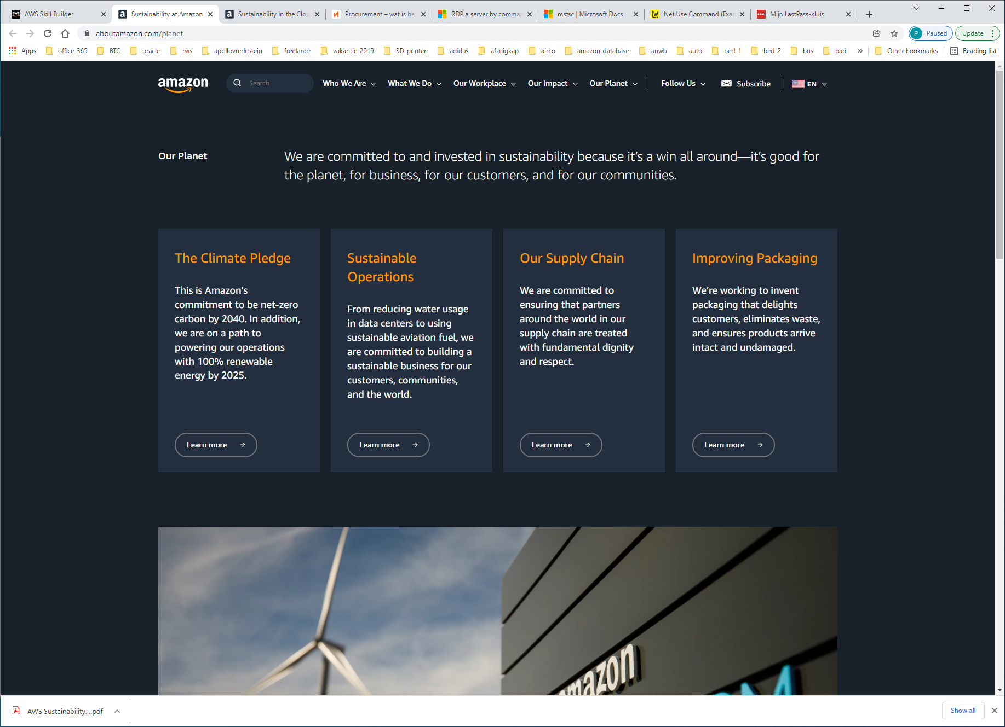

https://sustainability.aboutamazon.com/question-bank

